Pyrogen Marine Systems
Automatic fire suppression system using the Pyrogen SP-1e

Engineering, design and installation manual

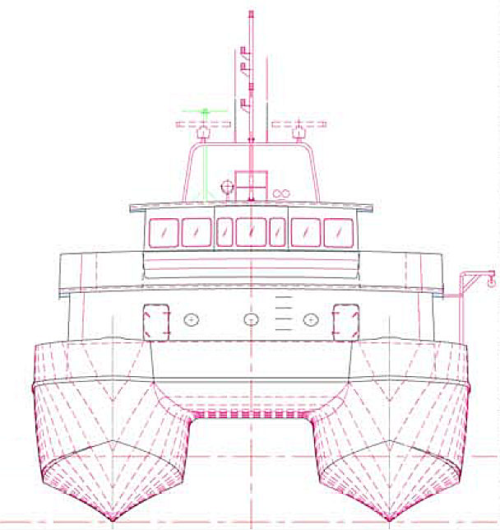

Table of contents
Forward |  |  |  | 7
Pyrogen Headquarters |  |  |  | 8
Australian/New Zealand Office |  |  |  | 8
Pyrogen North and South America |  |  |  | 8
User Instructions |  |  |  | 9
 |  |  | In the event of fire | 9
 |  |  | In the event of alarm | 9
 |  |  | In the event of fault | 9
 |  |  | Alarms | 9
General |  |  |  | 10
 |  |  | Pyrogen Sp-1e | 11
 |  |  | Fire extinguishing | 12
 |  |  | Functional description of the Pyrogen SP-1e | 12
 |  |  | When the system is discharged | 14
The System Components
 |  |  | The PYROGEN Generator | 15
 |  |  | The EXA Generator EXA-MB-10 | 16
 |  |  | The EXA generator EXA-30 50 | 17
 |  |  | What is Pyrogen | 18
 |  |  | How does Pyrogen work | 18
 |  |  | SP-1e Control Panel | 18
 |  |  | Monitoring | 19
 |  |  | Initial start up | 19
Health and Safety |  |  |  | 19
 |  |  | High Temperatures | 20
 |  |  | Hot work | 20
 |  |  | Cleaning after discharge | 20
 |  |  | Reduced Visibility | 21
 |  |  | Oxygen levels | 21
 |  |  | Toxicity | 21
 |  |  | Health considerations | 21
 |  |  | Noise | 22
 |  |  | Dangerous Goods and shipping | 22
Installation |  |  |  | 22
 |  |  | General | 20
Prior to Installation
 |  |  | Equipment and installation tools | 23
 |  |  | Tools | 23
 |  |  | Order of connection | 23
Installation of PYROGEN generators
 |  |  | Minimum Clearances limitations | 27
 |  |  | Height limitations | 27
 |  |  | Typical installations | 27
 |  |  | Mono Generator installation | 28
 |  |  | Bi-Nozzle generator installation | 28
Installation of EXA generators
 |  |  | Minimum Clearances limitations | 27
 |  |  | Height limitations | 27
 |  |  | Typical installations | 27
 |  |  | Mono Generator installation | 27
 |  |  | Bi-Nozzle generator installation | 28
Service & Maintenance |  |  |  | 29
 |  |  | General | 29
 |  |  | Service life | 29
After Discharge |  |  |  | 31
 |  |  | Replacing EXA and MAG generators | 31
Technical specifications |  |  |  | 32
 |  |  | Canister Characteristics | 33
 |  |  | Electrical Characteristics | 33
 |  |  | Aerosol Characteristics | 33
 |  |  | Classifications | 34
 |  |  | Technical parameters EXA | 35
 |  |  | Determining aerosol quantities | 36
Technical Specifications PyroSense SP-1e |  |  |  | 37
SP-1e Fire Alarm Control Panel (FACP) |  |  | Terminal Strip connections | 38
 |  |  | Conductors and cables | 39
 |  |  | Optional Accessories | 39
 |  |  | The sensor cable LHD Wire | 39
 |  |  | The DIP switches | 40
 |  |  | LED’s | 40
 |  |  | Power LED | 40
 |  |  | Activated LED | 41
Configuration Comments |  |  | The Generator release output | 41
 |  |  | Low power mode | 42
 |  |  | Start up sequence | 42
 |  |  | About the rules system | 42
 |  |  | The keyboard | 43
 |  |  | Resetting | 43
 |  |  | Silencing | 43
 |  |  | Modes | 43
 |  |  | Current sensing monitoring | 44
 |  |  | Software priorities | 44
Thermal Activation |  |  |  | 44
Technical Data PyroSense SP-1e |  |  |  | 47
Setting the DIP switches |  |  |  | 48
 |  |  | Cause effect Matrix | 47
 |  |  | Monitoring of Pyrotechnical discharge | 50
 |  |  | Warnings | 51
 |  |  | Fault conditions | 54
Configuration Comments |  |  |  | 55
Testing |  |  | General testing | 58
 |  |  | Stage-1 The DOP Switched and LED’s | 58
 |  |  | Stage-2 The analogue inputs | 59
 |  |  | Stage-3 The Outputs and remaining inputs | 61
 |  |  | Production testing | 63
Trouble Shooting |  |  |  | 64
 |  |  | General | 64
 |  |  | Power lamp out | 64
 |  | Fault LED lit |  | 65
 |  |  | Check generator and flying lead | 66
 |  |  | Check loop -1 Sensor cable | 67
 |  |  | Check loop -2 Alarm detectors | 68
 |  |  | Check external manual discharge loop | 69
 |  | Alarm LED lit |  | 71
 |  |  | Alarm and Activated LED lit | 72
List of delivered items |  |  |  | 73
Optional equipment |  |  |  | 74
Installation check list |  |  |  | 76
Service Log |  |  |  | 80
Declaration of conformity |  |  |  | 80
Illustrations
Installation diagram Basic Kit |  |  |  | 83
Installation diagram optional Webasto cabin heater protection |  |  |  | 82
Function: Bow thruster GenSets |  |  |  | 84
Thermal Electrical Activation |  |  |  | 84
Installation diagram optional delayed discharge |  |  |  | 85
Installation diagram optional Isolator switch |  |  |  | 87
Installation diagram optional Manual discharge button |  |  |  | 89
External Manual discharge button |  |  |  | 90
Installation diagram optional automatic Fan stop |  |  |  | 88
Installation diagram optional automatic Fan stop |  |  |  | 91
Installation diagrams for the connection of Alarm |  |  |  | 91
Sensors using NO alarm contacts |  |  |  | 93
 |  |  | Illustrations
 |  |  | Isolation Switch typical | 87
 |  |  | Manual discharge switch | 89
 |  |  | Manual discharge T-Start | 84
 |  |  | Automatic fan Stop | 90
 |  |  | Connection of alarm sensor (NC) | 92
 |  |  | Connection of alarm sensor (NO) | 92
 |  |  | T-Start Automatic discharge | 85
Notes
Sketches

FOREWORD

This Manual is intended for use with the Pyrogen Industrial Fire Suppression Systems manual. The systems are designed as fixed fire suppression systems for normally unoccupied areas.

Pyrogen systems for total flooding applications shall comply with the requirements of the following Standards:
- AS/NZS 4487:1997 Australia/New Zealand Standard
Pyrogen Fire Extinguishing Systems; and

- AS/NZS 1851.16:1997 Australia/New Zealand Standard
Maintenance of Fire Protection Equipment
Part 16: Pyrogen Fire Extinguishing Aerosol Systems

- NFPA 2010 Standard for Fixed Aerosol Fire Extinguishing Systems
2005 Edition

- CEN/TC 191 Fixed fire fighting systems – Condensed aerosol
extinguishing systems – Part 1: Requirements and test methods for components (WI00191148)

- CEN/TC 191 Fixed fire fighting systems – Condensed aerosol
extinguishing systems – Part 2: Design, Installation and Maintenance (WI00191149)

For the protection of a specified risk area a specific advice and approval may be required from an appropriate authority having jurisdiction.

Those who design, operate, own and maintain these systems should read the entire Manual. Specific sections would be of particular interest depending on one’s responsibility. If there should be any questions regarding this manual, please contact our representatives from a Pyrogen office below or contact the nearest Pyrogen Authorised Representative.

Where required persons who install and commission Pyrogen systems must be approved and certified by the Appropriate Authorities. System Design Approval Certificates must be completed and sent to a Pyrogen office for endorsement prior to supply and installation of a Pyrogen Fire Suppression System.

Approved companies may also be required to supply details to the Approval Authority prior to each installation and provide a Commissioning Certificate upon completion of the installation in the specified risk areas.

The Pyrogen Fire Suppression System requires minimal maintenance, mainly supervision of electrical circuitry, however the system should be inspected at regular intervals to provide maximum assurance that your fire suppression system will operate effectively and safely. Inspection and maintenance should be conducted in accordance with the inspection and maintenance schedule included in this Manual.

This Manual is limited for Marine use along with Pyrogen Industrial Fire Suppression Systems and within the requirements and the limitations of use detailed within this Manual.

Queries can be directed to Pyrogen personnel in the following Pyrogen offices:

Pyrogen Headquarters:

PYROGEN TECHNOLOGIES SDN. BHD.
No. 2A, Jalan SS13/3D,
Subang Jaya Industrial Estate,
47500 Subang Jaya,
Selangor Darul Ehsan,
Malaysia.

Tel.: +(60-3) 5621-2211
Fax: +(60-3) 5621-5566
Email: pyrogen@tm.net.my

Australian/ New Zealand Office:

PYROGEN TECHNOLOGIES (AUST) PTY. LTD.
18, Barry Avenue, Mortdale,
NSW 2223, Australia,
Tel.: +(61-2) 9586-3200
Fax: +(61-2) 9586-3211
Email: enquiries@pyrogen.com.au

Pyrogen North and South America:

FIREPAK OIL AND GAS INDUSTRIES IIC
7011 Harwin Dr Suite 290
Houston, Texas 77036
Tel.: +(1) 713-952-1996
Fax: +(1) 713 952 1997
Cell +(1) 360 941 2358
Email: mailto:jbrooks@pyrogen.com

This manual covers the installation of both the EXA series MAG series Pyrogen generators. The design concentrations and installation is the same for both styles of generators. The newer Stainless Steel EXA-Z3, EXA-Z6, EXA-1, EXA-2, EXA-5 EXA-MB5 and EXA-MB10 are interchangeable with the design and installation of the MAG series. The new larger EXA-10, EXA-20, EXA-30, EXA-50, are of a similar design but are larger in diameter. Installation is In Accordance of the guidance provided in NFPA 2010: Standard for Fixed Aerosol Fire Extinguishing Systems

User instructions
In the event of a Fire Alarm

- Sound the general alarm and notify the crew and guest of the fire and suspected location.
- The Fire Suppression system will be automatically released within 15 seconds form the activation of the alarm.
- Evacuate and escort guests to a safe area on deck away for the exhaust blowers and ducting for the alarmed space.
- Locate the portable extinguishers and prepare for manual intervention of the fire with the help of the portable extinguisher if required.
- Id possible, disconnect all power sources (electrical, gas air etc.) Note: This should only be attempted when it is considered safe to do so by the Master or Chief engineer.
- Muster all hands and check that all personnel are accounted for.
- Observe for reignition of fires and do not open any doors or hatches or ventilation for 5 minutes after the actuation of the fire suppression system. Note: The aerosol fire fighting agent looks like steam, do not excite or worry your guest. Pyrogen is non toxic and has no post combustion by products like HFC or CFC gas products.
- After 5 minutes only open door or hatches slightly and with extreme caution, ensuring the entry party is protected for the fire or gasses.
- After the fire party has verified the fire is out and the space cooled down start the ventilation blowers. This with dissipate the Pyrogen for the machinery space.
Copy or print the above and use this procedure for crew training.

In the event of an ALARM

When the ALARM appears on the control panel
- check to see if it is a fire or fault alarm
- If it is a Fire Alarm (i.e. Alarm LED Activated) See above “In the event of FIRE”
- If it is a Fault Alarm (i.e. Fault LED Activated) See Below “in the event of a FAULT”

In the event of Fault

- Check which lamps are illuminated and deactivate the acoustic alarm by pressing the left red button “ Silence ”
- follow the procedure on page 37
- When the reason for the fault has been detected and corrective action has been taken, the control panel can be reset by pressing the right red button “RESET”. It is not possible to reset the control panel until the corrective action has been carried out.

Alarms

Fire Alarm Alarm indicator illuminated and Buzzer continuous.
Discharged Activated indicator illuminated and Buzzer pulsates.
Fault Fault indicator illuminated and Buzzer continuous

General

PyroSense SP-1e

PyroSense™ Sp-1e is a combined alarm monitoring and discharge panel used for controlling Pyrogen Aerosol generators. It can be connected to and monitor information form Spot detectors of different types and thermal sensing cable inputs.

The control panel can be programmed to operate in either the automatic mode, which after receiving a signal form one of the detectors or sensors indication the existence of a fire; will release the agent for the Pyrogen generators remotely after a preset delay. Also available is Manual mode allowing for review of the alarm situation before the activation of Pyrogen generators for the panel. See chapter “APPLICATIONS”
PyroSense SP-1e is programmed at the manufacturing point to just indicate FIRE (i.e. Manual Mode) however the panel can be re-configured to an Automatic setting very easily by altering the DIP switches on the rear of the control panel. (Please review the table on page 28)
On the back of the panel there are a number of terminals that allow the user to connect external sounders, warning beacons, Pyrogen canisters as well as an external manual discharge button should one be required.

In the event of a fire the panel will illuminate and the ALARM LED and the warning sounder/beacon if connected will activate, if the panel is set in the MANUAL MODE the Pyrogen generators can only be activated by, simultaneously, Pressing and Holding the TWO RED Buttons on the front of the panel for five (5) Seconds. This will activate the discharge LED and the units will activate releasing the agent into the protected space. If the panel has been configured to operate in a fully Automatic mode the panel will, once it has received an indication of fire form one of the detector or sensor loops, automatically activate the Pyrogen generator releasing the agent into the protected space after a 15 second warning time.

In order to reset (stop) any activated sounders or beacons press the “SCILENCE” Button. The ALARM LED will remain illuminated and can only be reset by pressing the RED “RESET” button on the face of the panel

In the event that a fire was detected by the thermal cable or linear heat detection wire / LHD wire (PROTECTOWIRE) the FAULT LED will remain illuminated until the wire has been replaced and the 47K resistance EOL value restored to the input terminal.

Fire extinguishing

If the Pyrogen generator is discharged the LED “activated” will be illuminated, the external buzzer and sounder/flasher. If fitted will be pulsating. Pressing the red “Silence” Button will reset and silence the sounder.

If configured in the automatic mode, where the activation is done by signals form detectors, the “ALARM” LED will be illuminated as well.

If the sensor cable or LHD wire triggers the alarm, the LED in the control panel will remain illuminated until the LHD wire or sensor cable is renewed or disconnected. If the sensor cable is disconnected, only the fault LED will be indicated on the control panel. The FAULT signal will be given until the sensor cable is replaced or renewed. In the event of a fire the damaged section of the LHD cable and be cut out and replaced until the vessel reached its next port. This temporary spliced section is used to restore the End of Line resistance (47K) over the LHD loop. Undamaged sections of the protectowire will still provide early detection put the panel in alarm and sequence a release, but unless the Pyrogen generators have been replaced no suppression capability is available. Spare generators can be carried onboard and can be used to put the system back in service until the next port visit where the system should be renewed and checked by the local Pyrogen distributor.

Functional Description PyroSense SP-1e

The PyroSense system consist of a control panel, cables heat sensing or LHD cable (protecowire) and one or more Pyrogen generators.
The SP-1e control panel has two loops. Alarm loop 1 (one) is primarily used for the LHD wire or thermal sending cable, Loop 2 (two) can be used for spot heat detectors, smoke detectors or T-Starts thermal activation devices.

At temperatures greater >180 deg C the LHD wire or thermal cable connected to Alarm loop 1, will short circuit at the pre determined temperature based on the design of the wire itself. Protectowire is available in many temperature ranges. It is also available in dual temperature sensing cables that can provide alarm only and later automatic release for the same LHD cable. Check it you vessel design or commissioning documents for the type and temperature of the wire selected for your installation.
If the control panel is programmed for automatic mode the alarm will sound for 15 seconds prior to the discharge of the Pyrogen generator/s. In this mode output 2, 10 & 11 (see foot note ¹⁾ will be activated simultaneously with the alarm with out delay. This signal might be used to secure ventilation, and stop the engine. Output 1 (terminals 9&10) can be used for external sounders, deacons and other alarms.
The same will happen of the alarm signal is given from the detectors connected to loop 2.

Foot Note: ¹ The shutdown output can optionally be used as a second Pyrogen generator release output. When this mode is enabled (see page 28) the normal functionality of the shutdown system is no longer available.

In addition to alarm output, fan stop etc. Output two can be used as a second discharge loop. If configured (see page 27) this loop will activate automatically either as soon as the main output is activation is complete, i.e. 5 seconds after the initial discharge or with a 5 second delay after the main discharge loop, i.e. 10 seconds after the initial discharge, depending on the settings of the DIP switches.

As mentioned it is also possible to use one of these input loops to activate the automatic discharge of the Pyrogen generator and use the other input for activating the alarm only (Fire Alarm). Selection of which input loop to use for the alternative purposes is done by help of the functional DIP switches located on the rear of the control panel. For extra safety detectors might be connected in both loops, and the control panel programmed to discharge the Pyrogen generator only of the alarm signal is given form both detectors. One or more smoke detector providing alarm signal to the activation the sounders and flashers, but not providing a automatic release unless the spot heat detector or the LHD wire also provides a alarm signal to the SP-1. This double knock system provides the best assurance against false alarms and inadvertent discharge of the fire suppression system.
Discharge of the Pyrogen generators also can be activated by simultaneously pressing and holding. The two red pushbuttons on the front of the control panel marked “PRESS” for minimum 5 seconds. A pulsating sound will confirm that manual discharge signal is activated. After 5 seconds the sound will stop pulsating and a uniform constant sound will be herd. At this moment the Pyrogen generator will be activated and the agent discharged into the protected enclosure and extinguishes the fire within seconds.

PyroSense™ Sp-1e is prepared for using a manual external discharge button or break glass wall pull. This input is also monitored, and a short circuit or broken loop will give a fault indication.

In the event of a fire the visual and acoustic alarms will be continuous, and will turn to pulsating when the Pyrogen generator is discharged. Note: beacon and strobe units can also be programmed to provide and ISO coded tone and signal based on the requirements of the authority having jurisdiction.

Pressing the “Silence” button will reset output 1 (external sounder). The alarm signal will activate until the “Reset” button is pressed. If the fire detector is still activated, the output will again be activated. Pressing the “Reset” button with an actual heat detector or LHD signal to the SP-1e will reset the release delay and start the 20 second delay. Each time the Reset is pressed will restart the delay timing.

The SP-1e control panel is also fitted with a software updating connector for future up grading of the controlling software.

When the system is discharged

In the event that the system is used and the Pyrogen generators are discharged, they need to be replaced in order or bring the system back to operational status. (After discharge page 18). Pyrogen generators are not refillable, and are not hazardous and do not require any special handling. They can go into the trash, and on to a land fill, or recycled for as scrap metal.

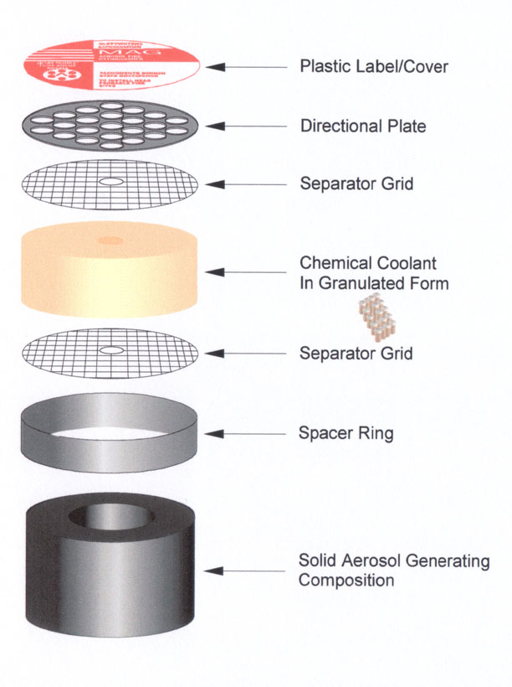 |  | Pyrogen Generator
The suppression system is based on the use of MAG generators directly activated by an electrical impulse from the control panel.

What is Pyrogen?
Pyrogen is a self-generated Aerosol Fire Extinguishing Agent, and is one of the most efficient Halon Alternative products currently available.

As the aerosol produced is self-generated it requires no pressure cylinders. Pyrogen's method of aerosol generation provides a sufficient driving force for a rapid discharge and efficient distribution of the extinguishing agent. No piping is required.

PYROGEN generators manufactured from marine grade are very compact and they are normally placed inside the protected enclosure.

Some Pyrogen units are called MAG generator (Mass Aerosol Generator).
Operation of the generator is either electrical automatic, electrical manual, thermal automatic or, on the grenade units, by pin removal.

MAG Series shown for clarification

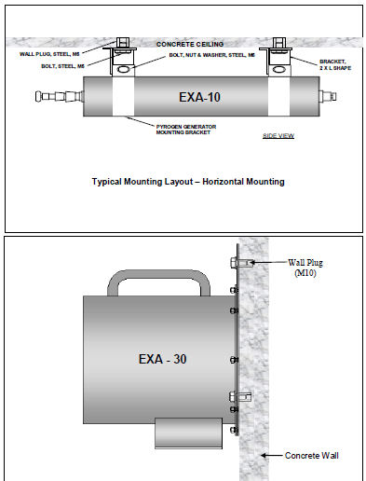
Typical EXA installation Welded studs replace concrete wall plugs

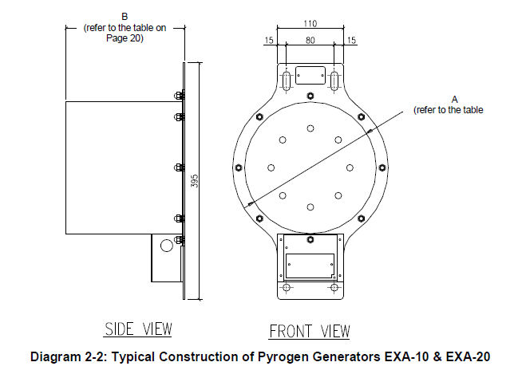
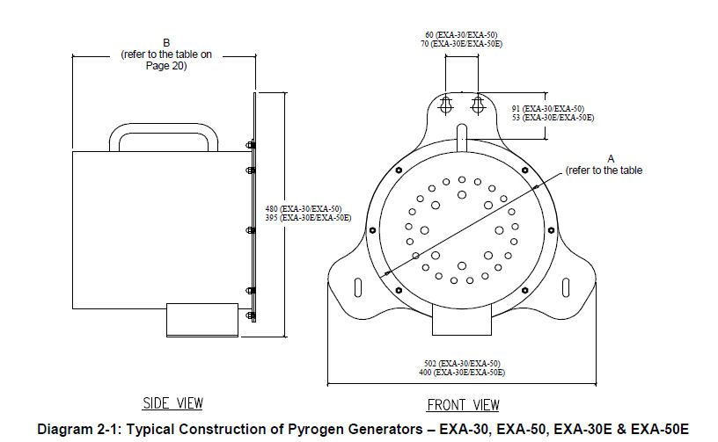

What is Pyrogen
Pyrogen is condensed aerosol. The active agent is a whitish gas like medium that is close to the density of nitrogen. It is made of small micron size potassium and carbon crystals. This small particle size ensures a three dimensional distribution and long suspension times.
Pyrogen is non conductive and non corrosive.
As Pyrogen aerosol stays in suspension for extended periods, it can be removed form the protected area by airflow. Any solid fraction of the aerosol agent that as settled can be easily brushed and vacuumed or washed away.

How does Pyrogen work?

The principle of extinguishing action employed by Pyrogen is unique, a special solid chemical, when electrically or thermally activated, produces combustion products, micron sized dry chemical particles & gases. Dry chemical particles (mainly potassium carbonates) & a gaseous mixture (mainly carbon dioxide, nitrogen & water vapor) mix together into a uniform fire-extinguishing aerosol.

Before being released into a protected area the hot aerosol propels itself through a unique solid chemical coolant, which decomposes absorbing huge amounts of heat, thus ensuring a flameless discharge and uniform distribution of the cool aerosol within the area.

The high rate of aerosol discharge ensures a tremendous knockdown effect. The micron sized particles exhibit gas-like three-dimensional qualities that allow the agent to rapidly distribute throughout the protected area and reach even the most concealed and shielded locations.

Homogenous distribution is achieved in a matter of seconds, while long holding times help to prevent any re-ignition of the fire.

The SP-1e control panel

The PyroSense SP-1e is an extremely compact control panel allowing adaptability to most standard instrument modules (VDO instruments). The panel front is both robust and water resistant. All cables, whether they are for the detectors, power supply or for the PYROGEN generators are connected at the rear of the panel.


Monitoring
Power
Fault
Alarm
Activated
Silence
Reset
Press both buttons
for 5 sec.
IN THE EVENT
OF FIRE
PRESS
Fire Control
PRESS

All inputs will be monitored continuously assuming that the panel remains connected to the power supply. Any short or open circuit signals will result in a “Fault” alarm.

Initial start up

When electrical source is first connected to the panel a start up/system test procedure automatically will commence. This will involve all the LED’s illuminating in sequence and the internal sounder will give a sequential tone. When this sequence has finished, the system is operational and provided no alarm or fault signal from any of the loops, and that the power source remains healthy, the "Power" lamp will illuminate.

Note! In order to save power the “Power” LED does not illuminate until the ignition is switched on (connected to terminal 14).

Should the user wish to run the start up/system test procedure at any time, this can be achieved by pressing the "Silence" button while electrical power is connected (see page 33). This will ensure all inputs & outputs are healthy.

WARNING! Prior to such a test it is important to replace the PYROGEN generator with a test lamp or the Red LED+ resistor originally supplied in terminals 3 & 4. Under no circumstances should tests be carried out with the PYROGEN generators electrically connected

Health & Safety

One of the main advantages of Pyrogen, compared to conventional chemical extinguishing agents, is the fact that Pyrogen does not decompose into damaging by-products when in contact with hot surfaces. This in fact means no secondary damage can be caused after the discharge of the extinguishing agent.

For safety reasons care should be taken not to expose people to the atmosphere in the enclosure immediately after discharge of Pyrogen. The enclosure should preferably be ventilated, directly into the open air. Inhalation of the decomposition products from the fire itself or inhalation of the Pyrogen aerosol should be avoided. If for any reason it is a necessary to enter the protected area prior to ventilation having taken place, suitable RPE & other available means of protection should be used.

High temperatures

During discharge the Pyrogen generator can reach temperatures of approximately 2ooC at the end cover (the nozzle) therefore it is important that the minimum safe distances be observed when the installation of the PYROGEN generators is being considered. Please see the table on page 14. Temperatures beyond the minimum safe distances will not exceed 75C

Hot work

As naked flame or prolonged exposure to temperatures above 300°C may cause activation of the generators, hot work must not be carried out within the vicinity of any generator or thermal sensing cables. If hot works are absolutely necessary the Pyrogen generators & thermal cables should be removed to a safe area prior to any work being carried out. It is also possible to fit an Isolator switch to avoid disconnecting all the PYROGEN connectors. This switch can also be used for testing the system.

Cleaning after discharge

Following a system discharge the aerosol particles that have settled should be vacuumed, blown, brushed or, if appropriate, washed away. Protective gloves and goggles should be worn. A respirator or mask should be worn. Large amounts of residue that are allowed to absorb moisture may become electrically conductive over a period of time.

Reduced visibility

Pyrogen is intended for use in normally unoccupied areas principally due to the high obscuration caused by the aerosol during and after discharge. Studies have shown that floor escape lighting (airliner escape lighting) and 5.6Nm green laser light beams or directional sound is proven methods to mitigate visual obscurity.

Oxygen level
Pyrogen chemically attacks the fire by breaking the flame chain reaction. It does not extinguish fires by oxygen depletion. After discharge, oxygen levels will remain at or about normal.

Toxicity

Inadvertent exposure to Pyrogen aerosol should always be avoided. Toxicological information refers to an inadvertent exposure to the aerosol in the event of accidental discharge in a non-fire situation. Pyrogen at design concentrations has a no effect NOEL of 15 minutes.

The main ingredients of the Pyrogen aerosol are solid potassium carbonates, nitrogen gas, carbon dioxide gas and water vapor. At normal extinguishing concentrations these products present little health hazard to personnel. However, small amounts of potentially hazardous by-products of the aerosol-generating combustion reaction, such as carbon monoxide and nitrogen oxides will be produced. Their actual concentrations depend on Pyrogen design factor used and type of enclosure being protected. Their toxicological characteristics depend upon the actual concentrations achieved and duration of exposure.

Exposure to a Pyrogen design factor of 100 g/m³, which is typical for class B fires in total flooding applications, for up to 5 minutes, is normally considered to represent a minor risk to personnel and may cause only moderate local irritation of the upper respiratory tract and to the eyes.
Health considerations

A by-product of Pyrogen aerosol-generating combustion reaction is fine potassium carbonate particles, small enough to be inhaled by persons not wearing RPE. There are no known toxicological long-term effects of these soluble micron sized particles, and physiological effects of deep lung penetration are usually a concern for insoluble sub-micron particles as they can interfere with pulmonary functions.

However, there are clear European guidelines controlling the exposure of persons to fine particles, irrespective of their nature. Further information is available in BS EN 481:1993 & BS EN 451:1993, and in CoSHH supportive documents EH40/98 & EH44 and MDHS 14/2.

Noise

The sound output & frequency at the time of activation and during discharge is similar to that produced by other extinguishing agents. Consequently, no specific precautions need to be taken.

Dangerous Goods Classification

Pyrogen is a DG Class 4.1 flammable solid N.O.S. in accordance with the United Nations ICAO and IMO Dangerous Goods Classification Code. Pyrogen generators have two ICAO UN numbers based on the type of potassium used. MAG generators are UN1325 (organic Potassium) and the EXA series are UN 3178 (inorganic potassium)

Installation

General

Prior to installation of any Pyrogen system the engine must be shut down and the main battery breaker disconnected. The main breaker shall not be reconnected until the installation is finalized. Please ensure that you have read the installation manual carefully, planned and prepared the installation in detail, and have ensured that you have all equipment and tools required available prior to start up of the installation.

Prior to Installation

The following equipment / materials should be prepared prior to installation:

Equipment and material

- Fireproof screened cable (X x 0.75 – the number of wires depend upon system configuration- see installation examples).
- Available outlet on the fuse box (3A).
- Junction box.
- Fastening equipment (cable clips, screws, Scotch tape, cable strips etc.).
- Sensor cable for heat detection (red type -180ºC).
- Adhesive sign "Warning" (SPE-PYR-3).
- Adhesive sign "Service" (SPE-PYR-2).
- PyroSense SP-1e control unit.
- PYROGEN generator(s) & brackets.
- Flying leads, connector cables for PYROGEN generator(s).

Tools

- Hand tools screwdriver and pincers
- Drill with 3.0 & 10mm drill bit
- Hole cutter for making circular hole with 60mm Ø (if SP-1e is to be flush mounted)
- Spanners for fixing PYROGEN brackets (M10)
- digital multi meter and leads

Order of connection
NOTE: The Pyrogen generators should not be connected until it is specified to do so.

- Turn off the engine and disconnect the batteries main breaker.
- Make a 60mm hole for the control panel. Alternatively the control panel may be installed in a spare instrument module, or separate box. It is important that the control panel (SP-1E) is installed in an easily accessible space, nearby the drivers’ position.
- Fix the Pyrogen generator/s and the thermal sensing cable.
- Install the junction box in the vicinity of the engine space or in the engine space itself.
- Install cable from the control panel (SP-1e) and the junction box (for connection of PYROGEN generator/s and for the sensor cable).
- Install the wire from SP-1e to the ignition switch/main breaker (Red 1 x 0.75mm²)
- Install the cable from the fuse box to the control panel SP-1e (2 x 0.75 mm²)
- Install the cables for auxiliary equipment such as sounders and beacons.
- Connect the thermal sensing cable to the junction box.
- Connect any sounder, beacon or connection to existing sounder.
- Connect wire from main ignition switch/ main breaker to PyroSense SP-1e control panel³.
- Connect wires for power in the fuse box and PyroSense SP-1e control panel.
- Configure the DIP-switches for the installation (rear of panel).
- Confirm & verify all the connections.
- Reconnect the battery main breaker.
- Switch on the ignition & check that the "Power" LED on the control panel is illuminated.
- Check to ensure that neither the “Alarm” nor "Activated" LED’s are activated on the SP-1e control panel. The "Fault" LED will be illuminated and the buzzer will sound as the Pyrogen generators have not yet been connected. However before proceeding further with the installation procedure, check to ensure that at this stage the cables leading to and intended for the PYROGEN generators are carrying no current beyond the expected monitoring current (between 1-5 mA). Use high impedance digital multi-meter set to 2 A
- If OK, switch the ignition off and disconnect the battery main breaker.

Note: It is important that prior to the installation of PYROGEN generators the integrity and resistance of the electric ignition circuit for each PYROGEN generator be checked with the use of a high impedance digital multi-meter. The maximum test current shall not exceed 50 milliamps for a period of 5 minutes. The monitoring current shall not exceed 5 milliamps.

Resistance of the electric activation circuit on each PYROGEN generator shall be within 2.5-4.5Ω. As the PYROGEN generators are connected in series for monitoring reasons the total resistance of the activation circuit connected to the SP-1e control panel should not exceed 20Ω on a 24 V DC power supply system.

It is also important to check ground fault of every PYROGEN generator. Earth fault resistance must not be less than 10mΩ. DO NOT USE A MEGGER FOR ISOLATION MEASURING. Only use a digital multimeter.

WARNING! Prior to connecting PYROGEN generators ensure the wires leading to the generators are carrying no current beyond the expected monitoring current.
Connection of PYROGEN generators should always be the last function in electrical wiring procedure.

- Connect the PYROGEN generator/s.
- Re-connect the battery main breaker.
- Switch on the ignition.
- After the control panel has run through the initially start-up sequence the "Power" LED should be the only LED illuminated.
- Fix “Warning” signs & operating instructions as well as any location specific Fire procedure instructions.
- Affix Installation date, future service date & maintenance or replacement date information on the PYROGEN generator.
- Finally ensure that the Installation details, maintenance protocol and checklist on pages 47-48 have been completed.

If at this point, or indeed at any point during the installation, there are any problems with the system, please refer to the chapter on “Trouble Shooting.
Installation of the PYROGEN generator

The Pyrogen generator/s should be installed in the best possible position to ensure that the aerosol will have chance to mix evenly within the, to be, protected area. Areas where the PYROGEN generator will be exposed to high temperatures (+50ºC) or high humidity should be avoided. Also due to the high temperature of the aerosol on discharge it is advised to ensure that they are not directed towards sensitive or delicate instrumentation.
Care should be taken to ensure that the positioning of the PYROGEN generators is beyond the specified safe distances, as shown in the table below, and the required safe distance for the PYROGEN type is observed.

Minimum clearances

MAG-02 |  | 150 mm
MAG-1 |  | 300 mm
MAG-2 |  | 400 mm
MAG-3 |  | 700 mm
MAG-4 (From each end) |  | 1000 mm
MAG-5  MAG 5/2 (From each end) |  | 700 mm

Table 1
The Pyrogen generators come in two distinct types. MAG series and EXA series both have “Mono” versions with one end plate nozzle i.e. activating from one end (these include the MAG 1, 2, 3 & 5 EXA-Z-6, EXA-Z3 EXA-1 EXA-2 EXA-5 , -10R/L, -20, -30, -50) and the “Bi-directional versions” with two end plate nozzles i.e. activating half their capability from each end (these include the MAG 4 & 5/2 EXA-MB-5, EXA-MB10)). If a “Mono” type MAG/EXA is to be installed, it can be fitted in such a way to direct the aerosol towards the area of considered risk. If the “Bi-directional” MAG is to be fitted, this should be fitted in the centre of the area to be protected to allow the low of aerosol over both side of the area of considered risk. Short elbows and ducts are available form you Pyrogen distributor.

When more than one PYROGEN generator is to be connected to the PyroSense SP-1e control Panel they should be connected in series to ensure that the control panel will monitor all generators.

See page 10-11 for Health & safety instructions prior to any installation of PYROGEN generators.

Limitations

The Pyrogen extinguishant, being a hot aerosol, has a tendency to rise upward on its release due to buoyancy forces (low specific weight compared to air). As such, the aspect of spatial distribution needs to be addressed. Therefore in order to ensure an even distribution it requires that a height limitation for the protected enclosure be set for each individual Pyrogen generators:

Height Limitations

MAG-1 |  | 1000 mm
MAG-2 |  | 1250 mm
MAG-3 |  | 2500 mm
MAG-4 – MAG-5 |  | 3000 mm

Table 2

NOTE! It is important to be aware off the fact that Pyrogen requires a sealed, or as sealed as is possible; area & that any openings in the engine space compartment will cause leakage of Pyrogen aerosol. This could, in a worst-case scenario, lead to fire not being extinguished. Therefore it is of vital importance that all hatches & ventilation fans be closed and the engine are stopped prior to discharge.

Typical installations

MAG’S 1 - MAG 5 are attached by using the supplied bands or brackets. For “mono” type extinguishers (MAG 1, MAG 2, MAG 3 & MAG 5/1) arrange the band around the centre of the casing. For “bi-directional” type extinguishers (MAG 4 & MAG 5/2), two bands should be used, these should be at a suitable distance from either end, to allow good support and fixing The MAG 4 has a special bracket arrangement that requires the bands to be fitted at each end of the generator. Ensure that the bands & brackets are tightened sufficiently using suitable spanners, and make sure that the unit is well held.

2
3
1
4
4
4
1
1 & 4

Installation of “mono” type generator with band fixing

Bolt M6 & washer
Band
Pyrogen MAG Generator
Nut M6 & washer

Installation of “mono” type generator with band fixing using an alternative bracket arrangement
Bolt M6 & washer
Band
Pyrogen MAG Generator
Nut M6 & washer

2
3
4
1
1
1
4
4

Mono Generator Fixings

Bi-Directional Generator Fixings

These fixing brackets could be used on MAG 4 and MAG 5 canisters only.

1
1
4
5

Installation of MAG 4 generator with band fixing & special end brackets

M6 Bolt & Washer
M6 Nut & Washer
MAG 4 generator
Band fixings
Special end bracket

2
3
1
2
5
4
2
1

2
1
3
4
5
6
Installation of “bi-directional” type generator with band fixing

Bolt M6 & Washer
Fixing Bracket 1
Wall Plugs
M6 Bolt Nut & Washer
Pyrogen MAG Generator
Band Brackets

Service & Maintenance

General

WARNING! Prior to the start of ANY maintenance work in the engine space or at the extinguishing system, always ensure as the first step that wiring to all Pyrogen generator loops have been electrically isolated (either by disconnecting the flying leads cables from the PYROGEN generator(s) or by setting the optional Isolator switch in Isolated mode). Should thermal automatic (T-Start) operation be used (normally used in Bow Thrusters or electrical load center system space), unscrew the fire conducting cord holders from the Pyrogen generator(s) and replace them with the end caps originally supplied. Failure to do so may result in unwanted spurious discharge.

The PyroSense SP1e does not require any direct maintenance, as the panel is self-monitoring; however it is important that a visual inspection of all the elements of the system, including Sensor cable, Sounders, Beacons and Pyrogen Generators, is performed on a monthly basis to ensure that no part of the system has been damaged. Any items found to be cracked, dented or loose should be rectified or replaced.

The visual inspection should consist of:

- Checking that all cabling is securely fastened and that the insulation is not damaged.
- Checking that all electrical connections and junction boxes are properly sealed. Moisture and/or corrosion in connections or junction boxes may, at worst case, discharge the system.
- Checking that the Pyrogen unit is not dented or damaged (In the event that a PYROGEN generator has been damaged or dented it should be disconnected and replaced immediately) and that it has remained properly secured in its fixings.
- Checking the replacement date for the PYROGEN unit.
- Ensure that no obstacles have been placed in front of the PYROGEN unit’s discharge nozzle (end plates) See installation instructions page 12-16.

Service Life
The service life of the Pyrogen unit in local applications under conditions of aggressive environment conditions (as for vehicle systems) is specified as 5 -7 years from installation. This time period is given as a typical example. For further clarification of the service life please contact your local Pyrogen distributor.
For the disposal of un-discharged generators please contact Pyrogen or your local Pyrogen supplier:

After discharge

Once a Pyrogen Generator has been activated it is no longer of any use and must be replaced with a complete unit. If the sensor cable has activated the system then this will need to be replaced also.

Disposal of deactivated Pyrogen generators can be made along with general waste as the remaining canisters contain on harmful materials. However if the spent canisters are returned to Pyroshield Ltd. or one of Pyrogen’s distributors, along with a detailed report on the incident that lead to the activation, new generators may be purchased at a reduced cost.

Replacing of a PYROGEN generator

WARNING! When replacing Pyrogen generators, be aware that immediately after discharge the canisters outer surface may exceed 100°C. Therefore, protective gloves should be worn before handling generators until at least 15 minutes after discharge.

- Disconnect the power supply for the control panel (or disconnect main battery breaker).
- Disconnect the connector on the spent (discharged) PYROGEN generator(s).
- Remove the spent (discharged) PYROGEN generator(s) from the bracket(s). Please note the warning at the top of this section.
- If the discharge was due to a signal from the Thermal sensing cable install a new cable.
- After ensuring that the brackets and fixings are okay fit the new PYROGEN generator.
Ensure that should there be any damage to the connector or flying lead this is replaced.
- Reconnect the power supply to the control panel (connect battery main breaker).
- Switch on the ignition

WARNING! Prior to connecting Pyrogen generators ensure the wires leading to the generators are not carrying any current beyond the expected monitoring current. Connection of PYROGEN generators should always be the last function in electrical wiring procedure.

It is important that prior to the installation of new PYROGEN generators the integrity and resistance of the electric activation circuit for each PYROGEN generator be checked with the use of a high impedance digital multi-meter. Each PYROGEN generator shall be within 2.5-4.5Ω. As the PYROGEN generators are connected in series for monitoring reasons the total resistance of the activation circuit connected to the SP-1e control panel should not exceed 20Ω on a 24 V DC power supply system.
The maximum test current shall not exceed 50 milliamps for a period of 5 minutes. The monitoring current shall not exceed 5 milliamps.

It is also important to check earth fault of every PYROGEN generator. Earth fault resistance must not be less than 10mΩ.

DO NOT USE A MEGGER FOR ISOLATION MEASURING.

- Reconnect the PYROGEN Generator(s) once the connector has been tested to ensure it is carrying no current (beyond the expected monitoring current).
- Ensure that the control panel does not indicate any "Fault".

Technical Specification ‘Pyrogen’

Pyrogen Generator

Canister Characteristics

Material |  | Marine Grade Aluminum
Max/Min Ambient |  | - 50°C ~ + 60°C
Shock |  | Tested to 10g for > 13,000 Impacts
Vibration |  | 5g @ 50 ~ 250Hz
Corrosion Resistance |  | Greater than UL 1058
IP Rating |  | IP558
Humidity |  | ≤96%

Electrical Characteristics

Supervision/Monitoring Circuit |  | ≤1mA
Activation |  | ≤400mA @ 6/12/24V for 10mS
Connector |  | 4 pin Military Type 2 PMDT Analog MIL-C-5015

Aerosol Characteristics (At Maximum Design Concentration)

Potassium Carbonates, solid |  | ~ 7g/M3
Nitrogen Gas |  | ~ 70% by vol.
Carbon Dioxide Gas |  | ~ 1.2% by vol.
Carbon Monoxide Gas |  | ~ 0.4% by vol.
Nitrogen Oxide Gas |  | 40 – 100 ppm.
Ammonia Gas |  | ~ 0.075% by vol.
Temp at Nozzle + 1,000 mm |  | ≤ 75°C
Oxygen (level) |  | 17% to 21% (typical)
Holding Time |  | ≤ 60 mins

Classifications

Suitable for fires |  | Class A – Combustible Solids  Class B – Flammable Liquids  Class C – Flammable Gases  Class E – Electrically Energized Fires  Class F – Fats & Cooking Oils
Handling & Transport |  | Accordance with ICAO UN 1325 & 3178  Dangerous Goods Code 4.1 Flammable Solid N.O.S.  Haz. Chem. Code 2[Y] E
Packaging Group |  | III

Technical parameters of PYROGEN canisters

2.6 Pyrogen EXA Range

Pyrogen comes in a form of small non-pressurised canisters with one or two end-plate delivery nozzles. The new canisters are called EXA generators and vary in size depending on the mass of solid aerosol-generating compound contained in the generator. Technical parameters of the current range of EXA generators are as follows:

TABLE 2-1
 | GENERAL SERIES
Parameter EXA | Z3 | Z6 | 1 | 2 | 5 | 10 | 20 | 30 | 50
- Mass of generator, g | 325 | 650 | 750 | 1,000 | 2,000 | 2,200 | 15,000 | 23,500 | 36,000
- Mass of aerosol-generating compound, g | 30 | 60 | 100 | 200 | 500 | 1,000 | 2,000 | 3,000 | 5,000
- Max protected volume m³ | 0.3 | 0.6 | 1 | 2 | 5 | 10 | 20 | 30 | 50
- Nozzle outlet | Mono | Mono | Mono | Mono | Mono | Mono/Bi | Mono | Mono | Mono
- Length of generator, B (mm) | 173 | 88 | 117 | 148 | 192 | 363 | 180 | 245 | 235
- Diameter of generator, A (mm) | 32 | 63 | 63 | 63 | 89 | 89 | 245 | 245 | 305
- Discharge time, s | <5.0 | <10.0 | <15.0 | <15.0 | <15.0 | <20.0 | <25.0 | <30.0 | <60.0

M-SERIES
Parameter EXA | M-Z2 | M-Z6 | MS-1 | ML-1 | M-2 | M-5 | M-10 | MB-10
Mass of generator, g | 300 | 650 | 800 | 800 | 1,200 | 2,300 | 4,200 | 4,200
Mass of aerosol-generating compound, g | 20 | 60 | 100 | 100 | 200 | 500 | 1,000 | 1,000
Max protected volume m³ | 0.2 | 0.6 | 1 | 1 | 2 | 5 | 10 | 10
Nozzle outlet | mono | Mono | Mono | Mono | Mono | Mono | Mono | Bi
Length of generator, B (mm) | 136 | 216 | 161 | 296 | 219 | 268 | 460 | 460
- Diameter of generator, A (mm) | 40 | 40 | 70 | 40 | 70 | 113 | 113 | 113
- Discharge time, s | <5.0 | <10.0 | <15.0 | <15.0 | <15.0 | <15.0 | <20 | <20

¹ Based on Design application density of 100g/m³

Technical parameters of the relevant range of PYROGEN MAG canisters are as follows:

Parameter | MAG | MAG | MAG | MAG | MAG | MAG
 | 1 | 2 | 3 | 4 | 5 | 5/2
Total Aerosol Mass Of Generator (g) | 60 | 100 | 200 | 1000 | 500 | 500
Protected Volume (m³ @ 100g per m³) | 0.60 | 1.0 | 2.0 | 10.0 | 5.0 | 5.0
Protected Volume (m³ @ 250g per m³) | 0.24 | 0.4 | 0.8 | 4.0 | 2.0 | 2.0
Protected Volume (m³ @ 300g per m³) | 0.2 | 0.3 | 0.6 | 3.3 | 1.6 | 1.6
Generator Type (Mono or Bi-Directional) | Mono | Mono | Mono | Bi | Mono | Bi
Length of Generator (mm) | 75 | 90 | 135 | 375 | 200 | 300
Diameter of Generator (mm) | 75 | 75 | 75 | 95 | 95 | 75
Discharge Time (s) | <3.5 | <6.0 | <7.5 | <10.0 | <7.5 | <7.5

Table 3

Determining the quantities of PYROGEN canisters

In order to define the number and type of PYROGEN canisters the gross volume of the protected space must be calculated. It is important to not subtract for any equipment within the protected space. Hence the calculation should be based on the actual engine area plus the space directly below (if open). When calculating the concentration one should allow for losses of aerosol through open areas, which always will occur in vehicles engine areas.
With this in mind a higher concentration of aerosol than the normally 100 grams per m³ must be configured. The design concentration for buses therefore shall be 200-300 gms per m³ (depending upon the actually space, openings etc), and this concentration must be maintained during a period of 10-15 seconds after discharge.
For some systems it may be necessary to have a secondary discharge shortly after the original to aid concentration hold times due to lost medium.
Minimum concentration is 600 grams aerosol mass (2m³ engine spaces @ 300 grams per m³).

The table above shows the relevant range of PYROGEN canisters, and the coverage of each type for different concentrations.

Technical Specification PyroSense SP-1e
SP-1e Fire Alarm Control Panel (FACP)

The terminals on the SP-1e are of screw/clamp type. Make sure that a suitable amount of the insulation on the cables/wires is removed and tighten down the terminal screw until the wire is securely held. It is only recommended that one conductor be placed in each terminal & that the maximum conductor size be 1.5mm² . (14Ga)

Power
Fault
Alarm
Activated
Silence
Reset
Press both buttons
for 5 sec.
PRESS
Fire Control
PRESS
IN THE EVENT
OF FIRE

It is suggested that all out cable sheaths are removed at approximately 300mm from the ends of the cables, and only internal cores be brought to the SP-1e control panel for fixing at the terminals. All cables should be anchored via cable clips or cable tied to other cable bundles.
The terminal strips can easily be removed from the SP-1e allowing the installer to connect all cables prior to fitting the control panel itself.

Terminal strip connections

- Battery (+) 12 or 24 V (Through a 3A fuse)

- Battery (-) GND.

- Pyrogen generator (-)

- Pyrogen generator (+)

- Input loop 2 (+)

- Input loop 2 (GND).

- Input Remote Manual Discharge Switch (+).

- Input Remote Manual Discharge Switch (GND).

- Out 1 (+)

- Out 1 & 2 (GND)

- Out 2 (+) / delayed 2. Shot (depending upon dip switch settings)

- Input loop 1 (+)

- Input loop 1 (GND).

- Ignition +

Conductors and cables

The conductors from the control panel to the sensor cable and to the PYROGEN unit must be as short as possible. The conductors shall have a minimum size of 0. 5mm², and the maximum length is 20 meters.
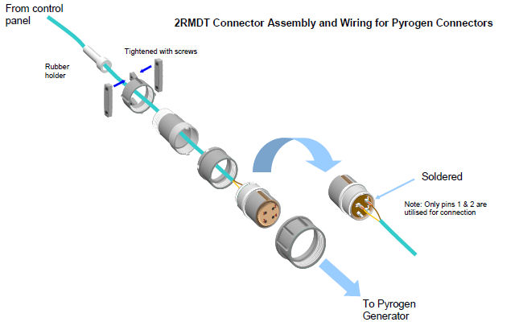

Optional accessories

Sounders and beacons should be situated in such a way that they can be easily heard, and seen, from the drivers’ position. If required extra sounders and beacons may be added in so that it is possible to hear and see them from all locations. It is also possible to connect existing sounders and/or beacons to the control panel.

NOTE! Ensure that either a beacon or sounder is visible or audible from the driver’s position.

The Sensor Cable

The Thermal Sensing cable is supplied complete with the End of Line (EOL) resistor required, and only needs to be connected at one end.
When installing the cable in the area to be protected it is important to install the cable at a point were possible fire risks may occur, and that any heat produced in the event of a fire can reach as greater amount of the circumference of the cable as is possible. When installing, & while considering the best routing of the cable, be careful to ensure that it is not to close to high running temperature items like exhaust manifolds etc. as this cable will activate at temperatures above 180°C.
The Thermal Sensing cable can be secured with the cable ties provided, however caution should be taken to ensure that these are not over tightened as this may cause the cable to short and give spurious indications.

WARNING! Ensure that, while the Thermal Sensing cable is securely fixed it is not over tightened.

The DIP switches

The eight DIP switches are used to select the functions for the two main alarm loop inputs, to enable automatic mode switching, for production test mode and to enable the second PYROGEN canister output. Their settings are summarized at page 27.

LED’s

Most of the LED’s actually consist of a pair of elements, so that if the main element stops working, the reserve element is lit. A feedback line is used to detect the state of the main element. The main element is known to work if the feedback line is low then the LED is activated and high when de-activated, so for constant monitoring, the main LED is in fact never entirely on or off, but will blink slightly. The blinking will be so fast that it is imperceptible, but it will allow the program to check the LED’s functionality.

Power LED

The power LED will be on constantly if the ignition in input indicates that the ignition is on.

Activated LED

The discharge LED has three separate and distinct speeds that it flashes at to show various stages of the discharge cycle. In the first 8 seconds, of the overall 15-second delay, it will flash at a slow regular rate. After the first 12 seconds and for the last three seconds of the delay the flashing speed will increase. Once the 15-second delay has finished and the Pyrogen generators are discharging the LED will flash at its fastest rate.
If a Manual and immediate discharge is chosen the LED will go straight to flashing at the highest rate.

The Pyrogen canister release output

This output has a current limiting regulation so that a constant current is driven out while it is activated. The output is a PWM (Pulse-Width Modulated) signal, so an output transistor is turned on and off rapidly (at approximately 940 Hz) to produce an average current of around 1 Amp.
The program will regulate the on- and off-times of the transistor to produce this average current, regardless of the load and regardless of the voltage. The regulation is not precise, but is designed to provide more than sufficient but not excessive current under a wide range of conditions.
The Pyrogen generator output is also time-limited. After activation, it will be automatically turned off after 5 seconds.
It is also possible to connect a second PYROGEN canister to the shutdown output, enabled using a dip switch. When enabled, this output will function exactly like the main PYROGEN Output, and will be activated for 5 seconds either as soon as the primary PYROGEN Output has been turned off (after 5 sec.), or after a delay of 5 seconds (total 10 sec. delay from start of first discharge),depending on the dip switch settings.
When this mode is active, the normal usage of shutdown (out 2) is unavailable.
Note that the second PYROGEN canister must be connected between the shutdown output and the normal PYROGEN Output ground connection (terminal 4).
The output will be checked for faults and for current-sense discharge monitoring in the same manner as the main canister output (both outputs must be successfully discharged before a discharge signal is recognized).

Low power mode

The SP-1e is inherently a low-power system. When everything is running normally with no alarms or warnings (driving the outputs or the LED’s inevitably draws significantly more current), the control panel draws in the region of 50mA. While this is small, it can be significant when there is no ignition to charge the battery. So when there is no ignition signal, the control panel will enter low power mode. In low power mode, the control panel draws in the region of 2mA.
Any fault, warning, alarm, or key press will wake the system from low power mode, with the exception of a fault in an LED, which will not wake the control panel.
Additionally, the software will wake up once per second to measure the various inputs. During this period, lasting around 8 ms, the control panel will again draw up to 50mA, and it will blink the power LED. If any of the signals are measured outside the normal good range, then the control panel will wake fully and take a complete filtered and averaged measurement as normal. Otherwise the control panel will return to low power mode after completing the measurements. This gives the software a slightly longer reaction time to external events (up to 1 second), but provides significant power savings. Note that the low power mode is in addition to the standard function of putting the processor to sleep for most of the time. The low power mode additionally turns off some of the electronics that is not necessary when not actually monitoring the inputs or driving the outputs.

Start-up sequence

When power is applied to the control panel, the system will run through all the LED’s in sequence, blinking both the main and reserve elements. When this sequence is complete (after about 2 seconds), the system is fully functional. Test mode is entered by holding down the silence key during this start-up sequence and for about 2 seconds more.

About the rules system

The program has a system of rules which are repeatedly checked (at a rate of 16 times per second). These are used to identify events in the system which should trigger changes in the outputs & alarms, LED display, and external outputs. Once a rule has been triggered, it continues to be active until it is explicitly reset. Even a short event on an external input is enough to cause some action (although internal filtering is used to avoid triggering events in the case of electrical noise or interference).

The keyboard

The SP-1e has two keys — Reset and Silence. The key inputs have internal filtering so that a definite press must be used to activate them. They do not have to be held long, but a brief glancing press may not be enough to activate them. The silence key is also used for testing purposes. If held down during power-on, it activates test mode, and if held down for 2 seconds during normal running, it activates a quick test of the LED’s.
The silence and reset keys can also be held down for 5 seconds to activate a manual discharge. While both these keys are held down, the external alarm (alarm Output 1) will sound rapidly. This provides audible feedback during the 5 second delay.

Resetting

Pressing the reset key will clear all current events, and de-activate all outputs. The system will then be returned to its idle monitoring mode. However, if any of the inputs still indicate events that trigger rules, the rules will be re-triggered immediately. Thus pressing reset will not disable any current events.

Silencing

Pressing the silence button will turn off the external alarm output (Out 1). Other outputs will be unaffected.
If another event occurs which should activate the external alarm, then they will be activated. Silence must be pressed again to silence the new event.

Modes

The SP-1e has two modes — auto and manual. The auto mode is the normal behavior for the SP-1e. In manual mode, most of the system will work normally, with the exception of rules that automatically start the discharge sequence. These will no longer activate the shutdown output (Out 2), nor will they start the discharge sequence. The alarm Output (Out 1) will still be activated, as will the appropriate LED’s. Manual discharge will function as usual.
Mode switching is enabled using DIP switch 5. If it is off, then the SP-1e will always be in auto mode. If it is on, then the system will change mode to auto whenever ignition is switched off, and change to manual whenever ignition is switched on.

Current sense monitoring

Discharge will also be confirmed during the PYROGEN canister discharge process—if the PYROGEN Output has been run for at least 1 second at 0.5 amps or more, then the discharge will be confirmed. If the control panel has been unable to drive 0.5 amps (for example, due to a damaged line) then the discharge will not be confirmed. This current-sense confirmation is in addition to the standard discharge confirmation used to monitor externally-initiated discharges.
Externally confirmed discharge monitoring, leads to flashing of the “Activated” LED, while the current sense monitoring leads to constant on “Activated” LED.
If the second PYROGEN canister output is enabled, then both discharges must be successful before being recognized as such by the current sense monitor.

Software priorities

More serious events always take priority over less serious events. Thus, if a rule calling for immediate discharge is activated, then it has first priority, followed by delayed initiation, followed by the various warning and alarm indicators.

Thermal activation

Thermal activation of the Pyrogen generator is provided by action of an inbuilt thermal ignition device & a linear thermal activation cord, which automatically ignites at ≤175° C or when exposed to a naked flame and propagates ignition to the solid aerosol-forming composition.
Do not crush the cord at any point and ensure that there is no possible risk of mechanical damage. The cord can be mounted by use of cable bands fixed with self-tapping screws. Ensure that the cord is not bent tightly at any point; a permissible bend is no less than 15mm radius. Thermal activation can also be done using our T-Start electrical current generator.

1
4
3
2
Typical drawing showing connection of thermal activation cord

MAG-generator
Thermal activation cord
Thermal activation cord exposed from protective braiding
Area for sealant

1
2
3
4
Typical drawing showing connection of thermal activation cord with the supplied bands

Band
Protected braiding
Thermal activation cord
Self tapping screws

Note: When installing, & while considering the best routing of the Thermal Activation device , be careful to ensure that it is not to close to high running temperature items like exhaust manifolds etc.

Technical data PyroSense SP-1e

Power supply | Operating voltage | 8 - 28 V dc
Power supply | Standby current (8 – 28 VDC) | 2 mA (ignition off)
Power supply | Normal current | 50 mA
Power supply | Internal automatic fuse | 2 A
Power supply | Fuse on supply lead (max) | 3A (5 A)
Ignition input | From ignition- or main switch | + 8 - 28 V dc (2 mA)
Alarm loop 1 (Thermal sensing cable) | Alarm Temperature | 180°C
Alarm loop 1 (Thermal sensing cable) | Maximum normal ambient temp | 105°C
Alarm loop 1 (Thermal sensing cable) | Voltage | 3 VDC
Alarm loop 1 (Thermal sensing cable) | Normal current/Alarm current | 0.03 / 0.06 mA
Alarm loop 1 (Thermal sensing cable) | Sensor cable EOL resistor | 47kΩ
Alarm loop 1 (Thermal sensing cable) | Alarm Situation | Short Circuit
Alarm loop 2 | Alarm situation, resistor value on loop | 47kΩ 
Alarm loop 2 | Norm. situation, resistor value on loop | 23,5kΩ 
Alarm loop 2 | EOL resistors on NC alarm contact | 2x47kΩ
Alarm loop 2 | Voltage | 3 VDC
Alarm loop 2 | Normal curent / Alarm curent | 0.03/ 0.12 mA
Remote manual discharge loop | Alarm situation, resistor value on loop | 47kΩ 
Remote manual discharge loop | Norm. situation, resistor value on loop | 23,5kΩ 
Remote manual discharge loop | EOL resistors on NC alarm contact | 2x47kΩ
Remote manual discharge loop | Voltage | 3 V dc
Remote manual discharge loop | Normal curent t t en t/ Alarm curent | 0,03/ 0,12 mA
Discharge signal | Duration (Pulse time) | 5 sec.
Discharge signal | Voltage | 8 - 28 V dc
Discharge signal | Discharge current (Max) | 1,2 A (current limited)
Discharge signal | Max number of MAG generators | 2 (12 V dc) or 4 (24 V dc)
Discharge monitoring | Voltage in sleep mode | < 20mV
Discharge monitoring | Voltage in awake & no load connected | 2.7 V dc
Discharge monitoring | Normal current 12V/24V | 0.25 / 1 mA
Sounder/Beacon connection (Output 1) | Voltage | 8 – 28 V dc
Sounder/Beacon connection (Output 1) | Current (max) | 1.8 A
Engine & ventilation shut down (Output 2) | Voltage | 8 – 28 V dc
Engine & ventilation shut down (Output 2) | Current (max) | 1.8 A
Second discharge output (Output 2) | Duration (Pulse time) | 5 sec.
Second discharge output (Output 2) | Voltage | 8 - 28 V dc
Second discharge output (Output 2) | Discharge current (Max) | 1,2 A (current limited)
Second discharge output (Output 2) | Max number of PYROGEN generators | 2 (12 V dc) or 4 (24 V dc)
Dimensions | Front L x W x D | 70 x 70 x 30 mm
Dimensions | Cut out | Ø 60 mm
Dimensions | Depth in cut out | 40 mm
Dimensions | Weight | 110 g
IP Rating | Flush & surface mounted | IP54 (IP65)
Limited life components | PYROGEN generator | Max. 10 year
Testing | LED test & a full test of all inputs and outputs as part of installation & service
The manufacturer reserves the right to amend specifications and details within this document, without prior notice.

Setting the DIP-switches - Cause effect matrix

Legend:

1=ON, 0=OF, X= No Effect
Continuous
Pulsating
Delayed discharge
Immediate discharge
Change from pulsating to continuous
Discharge 5 sec. after start of first discharge | +  5
Discharge 10 sec. after start of first discharge | +  10

Input status |  | Configuration |  |  |  |  |  |  |  | Actions
Setting of dip switches:  X= don’t care (could be either 0 or 1)  0= dip sw. set to off  1= dip sw. set to on | Ignition | DIP SWITCH SETTING |  |  |  |  |  |  |  | Output 1 | Output 2 | Alarm LED | Act. LED | PYROGEN 1 | PYROGEN 2 | NOTE
 | Ignition | 8 | 7 | 6 | 5 | 4 | 3 | 2 | 1
Input loop 1 in alarm situation | x | 0 | 0 | 0 | 0 | x | x | 1 | 0 |  |  |  |  |  | NA | 1
Input loop 2 in alarm situation | x | 0 | 0 | 0 | 0 | 1 | 0 | x | x |  |  |  |  |  | NA | 2
Input loop 1 & 2 in alarm situation | x | 0 | 0 | 0 | 0 | 1 | 1 | 1 | 1 |  |  |  |  |  | NA | 3
Input loop 1 in alarm situation | x | 0 | 0 | 0 | 0 | x | x | 1 | 1 |  |  |  |  |  | NA | 4
Input loop 2 in alarm situation | x | 0 | 0 | 0 | 0 | 1 | 1 | x | x |  |  |  |  |  | NA | 5
Input loop 1 in alarm situation | 1 | 0 | 0 | 0 | 1 | x | x | 1 | 0 |  |  |  |  |  | NA | 6
Input loop 2 in alarm situation | 1 | 0 | 0 | 0 | 1 | 1 | 0 | x | x |  |  |  |  |  | NA | 7
Input loop 1 & 2 in alarm situation | 1 | 0 | 0 | 0 | 1 | 1 | 1 | 1 | 1 |  |  |  |  |  | NA | 8
Input loop 1 in alarm situation | 0 | 0 | 0 | 0 | 1 | x | x | 1 | 0 |  |  |  |  |  | NA | 9
Input loop 2 in alarm situation | 0 | 0 | 0 | 0 | 1 | 1 | 0 | x | x |  |  |  |  |  | NA | 10
Input loop 1 & 2 in alarm situation | 0 | 0 | 0 | 0 | 1 | 1 | 1 | 1 | 1 |  |  |  |  |  | NA | 11
Input loop 1 in alarm situation | x | 0 | 1 | 0 | 0 | x | x | 1 | 0 |  | NA |  |  |  | +  5 | 12
Input loop 2 in alarm situation | x | 0 | 1 | 0 | 0 | 1 | 0 | x | x |  | NA |  |  |  | +  5 | 13
Input loop 1 & 2 in alarm situation | x | 0 | 1 | 0 | 0 | 1 | 1 | 1 | 1 |  | NA |  |  |  | +  5 | 14
Input loop 1 in alarm situation | x | 1 | 1 | 0 | 0 | x | x | 1 | 0 |  | NA |  |  |  | +  10 | 15
Input loop 2 in alarm situation | x | 1 | 1 | 0 | 0 | 1 | 0 | x | x |  | NA |  |  |  | +  10 | 16
Input loop 1 & 2 in alarm situation | x | 1 | 1 | 0 | 0 | 1 | 1 | 1 | 1 |  | NA |  |  |  | +  10 | 17
Input loop 1 in alarm situation | 1 | 0 | 1 | 0 | 1 | x | x | 1 | 0 |  | NA |  |  |  |  | 18
Input loop 2 in alarm situation | 1 | 0 | 1 | 0 | 1 | 1 | 0 | x | x |  | NA |  |  |  |  | 19
Input loop 1 & 2 in alarm situation | 1 | 0 | 1 | 0 | 1 | 1 | 1 | 1 | 1 |  | NA |  |  |  |  | 20
Input loop 1 in alarm situation | 0 | 0 | 1 | 0 | 1 | x | x | 1 | 0 |  | NA |  |  |  | +  5 | 21
Input loop 2 in alarm situation | 0 | 0 | 1 | 0 | 1 | 1 | 0 | x | x |  | NA |  |  |  | +  5 | 22
Input loop 1 & 2 in alarm situation | 0 | 0 | 1 | 0 | 1 | 1 | 1 | 1 | 1 |  | NA |  |  |  | +  5 | 23
Input loop 1 in alarm situation | 0 | 1 | 1 | 0 | 1 | x | x | 1 | 0 |  | NA |  |  |  | +  10 | 24
Input loop 2 in alarm situation | 0 | 1 | 1 | 0 | 1 | 1 | 0 | x | x |  | NA |  |  |  | +  10 | 25
Input loop 1 & 2 in alarm situation | 0 | 1 | 1 | 0 | 1 | 1 | 1 | 1 | 1 |  | NA |  |  |  | +  10 | 26
Input loop 1 in alarm situation | 1 | 1 | 1 | 0 | 1 | x | x | 1 | 0 |  | NA |  |  |  |  | 27
Input loop 2 in alarm situation | 1 | 1 | 1 | 0 | 1 | 1 | 0 | x | x |  | NA |  |  |  |  | 28
Input loop 1 & 2 in alarm situation | 1 | 1 | 1 | 0 | 1 | 1 | 1 | 1 | 1 |  | NA |  |  |  |  | 29
Manual discharge by front buttons | x | X | 0 | 0 | x | x | x | x | x |  |  |  |  |  | NA | 30
Remote manual discharge=Alarm | x | X | 0 | 0 | x | x | x | x | x |  |  |  |  |  | NA | 31
Manual discharge by front buttons | x | 0 | 1 | 0 | x | x | x | x | x |  | NA |  |  |  | +  5 | 32
Remote manual discharge=Alarm | x | 0 | 1 | 0 | x | x | x | x | x |  | NA |  |  |  | +  5 | 33
Manual discharge by front buttons | x | 1 | 1 | 0 | x | x | x | x | x |  | NA |  |  |  | +  10 | 34
Remote manual discharge=Alarm | x | 1 | 1 | 0 | x | x | x | x | x |  | NA |  |  |  | +  10 | 35

Table 4

Monitoring of pyrotechnical discharge

The following rules concerns monitoring of pyrotechnical discharge of a PYROGEN canister by use of an external thermal alarm contact on the PYROGEN canister being monitored.

Input status |  | Configuration |  |  |  |  |  |  |  | Actions
 | Ignition | DIP SWITCH SETTING |  |  |  |  |  |  |  | Output 1 | Output 2 | Alarm LED | Act. LED | PYROGEN 1 | PYROGEN 2 | NOTE
 | Ignition | 8 | 7 | 6 | 5 | 4 | 3 | 2 | 1
Input loop 1 in alarm situation | x | x | x | 0 | x | x | x | 0 | 1 |  |  |  |  |  | NA | 36
Input loop 2 in alarm situation | x | x | x | 0 | x | x | 1 | x | x |  |  |  |  |  | NA | 37
Table 5

Warnings

The following rules concerns configuring the input loops for warning indications (factory default).

Input status |  | Configuration |  |  |  |  |  |  |  | Actions
 | Ignition | DIP SWITCH SETTING |  |  |  |  |  |  |  | Output 1 | Output 2 | Alarm LED | Act. LED | PYROGEN 1 | PYROGEN 2 | NOTE
 | Ignition | 8 | 7 | 6 | 5 | 4 | 3 | 2 | 1
Input loop 1 in alarm situation | x | x | x | 0 | x | x | x | 0 | 0 |  |  |  |  |  | NA | 38
Input loop 2 in alarm situation | x | x | x | 0 | x | 0 | 0 | x | x |  |  |  |  |  | NA | 39
Table 6

1 | Alarm status on loop 1 causes a delayed (15 sec.) activation of the Pyrogen generator.  Alarm status = NC input (short circuit). Normal status = 47kΩ
2 | Alarm status on loop 2 causes a delayed (15 sec.) activation of the Pyrogen generator.  Alarm status = 47kΩ input. Normal status = 23,5kΩ
3 | Alarm status on both loop 1 & 2 causes a delayed (15 sec.) activation of the Pyrogen generator. Alarm status loop 1 = NC input (short circuit). Normal status = 47kΩ  Alarm status loop 2 = 47kΩ input. Normal status = 23,5kΩ
4 | Alarm status on loop 1 causes a shutdown (Out 2 used for shutdown of ventilation, engine, dampers etc.). This situation could occur if configured as for note 3, with alarm on one of the loops only. Alarm status = NC input (short circuit). Normal status = 47kΩ
5 | Alarm status on loop 2 causes a shutdown (Out 2 used for shutdown of ventilation, engine, dampers etc.). This situation could occur if configured as for note 3, with alarm on one of the loops only. Alarm status = 47kΩ input. Normal status = 23,5kΩ
6 | System set to Manual mode (controlled by ignition & DIP 5). Alarm status on loop 1 causes alarm only.
7 | System set to Manual mode (controlled by ignition & DIP 5). Alarm status on loop 2 causes alarm only.
8 | System set to Manual mode (controlled by ignition & DIP 5). Alarm status on loop 1&2 causes alarm only.
9 | System set to Auto mode (controlled by ignition & DIP 5). Alarm status on loop 1 causes a delayed (15 sec.) activation of the Pyrogen generator.
10 | System set to Auto mode (controlled by ignition & DIP 5). Alarm status on loop 2 causes a delayed (15 sec.) activation of the Pyrogen generator.
11 | System set to Auto mode (controlled by ignition & DIP 5). Alarm status on loop 1&2 causes a delayed (15 sec.) activation of the Pyrogen generator.
12 | Alarm status on loop 1 causes a delayed (15 sec.) activation of the primary Pyrogen generator. After a 5 sec. delay the secondary Pyrogen generator activates.
13 | Alarm status on loop 2 causes a delayed (15 sec.) activation of the primary Pyrogen generator. After a 5 sec. delay the secondary Pyrogen generator activates.
14 | Alarm status on loop 1&2 causes a delayed (15 sec.) activation of the primary Pyrogen generator. After a 5 sec. delay the secondary Pyrogen generator activates.
15 | Alarm status on loop 1 causes a delayed (15 sec.) activation of the primary Pyrogen generator. After a 10 sec. delay the secondary Pyrogen generator activates.
16 | Alarm status on loop 2 causes a delayed (15 sec.) activation of the primary Pyrogen generator. After a 10 sec. delay the secondary Pyrogen generator activates.
17 | Alarm status on loop 1&2 causes a delayed (15 sec.) activation of the primary Pyrogen generator. After a 10 sec. delay the secondary Pyrogen generator activates.
18 | System set to Manual mode (controlled by ignition & DIP 5). Alarm status on loop 1 causes alarm only.
19 | System set to Manual mode (controlled by ignition & DIP 5). Alarm status on loop 2 causes alarm only.
20 | System set to Manual mode (controlled by ignition & DIP 5). Alarm status on loop 1&2 causes alarm only.
21 | System set to Auto mode (controlled by ignition & DIP 5). Alarm status on loop 1 causes a delayed (15 sec.) activation of the primary Pyrogen generator. After a 5 sec. delay the secondary Pyrogen generator activates.
22 | System set to Auto mode (controlled by ignition & DIP 5). Alarm status on loop 2 causes a delayed (15 sec.) activation of the primary Pyrogen generator. After a 5 sec. delay the secondary Pyrogen generator activates.
23 | System set to Auto mode (controlled by ignition & DIP 5). Alarm status on loop 1&2 causes a delayed (15 sec.) activation of the primary Pyrogen generator. After a 5 sec. delay the secondary Pyrogen generator activates.

Fault conditions

The Fault LED will illuminate if:
- The cable for the Pyrogen MAG generators goes open
- The cable-loop for the external manual discharge button goes open or short circuit
- The alarm-loop 1 goes open
- The alarm-loop 2 goes open or short circuit
- There is a problem with any of the LED’s in the control panel. All LED’s are double and
the spare LED will take over if the main LED is broken.
- Unsuccessful discharge
Fault will be indicated by a continuous tone from the sounder connected, the "Fault” LED will be illuminated and output 1 will give a steady signal for any external siren or alarms that might be connected to the system.

Input status | Actions
 | Output 1 | Fault LED | NOTE
Input loop 1 in fault condition |  |  | 40
Input loop 2 in fault condition |  |  | 41
Remote manual discharge=fault |  |  | 42
Break in primary PYROGEN loop |  |  | 43
Break in secondary PYROGEN loop |  |  | 44
Unsuccessful discharge |  |  | 45
LED faults |  |  | 46
Table 7

Configuration comments

24 | System set to Auto mode (controlled by ignition & DIP 5). Alarm status on loop 1 causes a delayed (15 sec.) activation of the primary Pyrogen generator. After a 10 sec. delay the secondary Pyrogen generator activates.
25 | System set to Auto mode (controlled by ignition & DIP 5). Alarm status on loop 2 causes a delayed (15 sec.) activation of the primary Pyrogen generator. After a 10 sec. delay the secondary Pyrogen generator activates.
26 | System set to Auto mode (controlled by ignition & DIP 5). Alarm status on loop 1&2 causes a delayed (15 sec.) activation of the primary Pyrogen generator. After a 10 sec. delay the secondary Pyrogen generator activates.
27 | System set to Manual mode (controlled by ignition & DIP 5). Alarm status on loop 1 causes alarm only.
28 | System set to Manual mode (controlled by ignition & DIP 5). Alarm status on loop 2 causes alarm only.
29 | System set to Manual mode (controlled by ignition & DIP 5). Alarm status on loop 1&2 causes alarm only.
30 | By simultaneously pressing the push buttons marked "Press" on the control panel, the Pyrogen generator will be discharged. An intermittent warning sound on external sounder indicates that the generator is about to be discharged. If the buttons are released during the 5-second period the PYROGEN units will not discharge. After approx. 5 seconds with both buttons depressed simultaneously the intermittent alarm will be transferred to a continuous tone and the PYROGEN unit will be discharged.
31 | By activating a remote manual discharge button (if any) the PYROGEN generator will discharge. The indicator.
32 | By simultaneously pressing the push buttons marked "Press" on the control panel, the primary Pyrogen generator will be discharged. An intermittent warning sound on external sounder indicates that the PYROGEN generator is about to be discharged. If the buttons are released during the 5-second period the PYROGEN units will not discharge. After approx. 5 seconds with both buttons depressed simultaneously the intermittent alarm will be transferred to a continuous tone and the primary PYROGEN unit will be discharged. After a 5 sec. delay the secondary Pyrogen generator activates.
33 | By activating a remote manual discharge button (if any) the PRIMARY PYROGEN generator will discharge. After a 5 sec. delay the secondary Pyrogen generator activates.
34 | By simultaneously pressing the push buttons marked "Press" on the control panel, the primary Pyrogen generator will be discharged. An intermittent warning sound on external sounder indicates that the PYROGEN generator is about to be discharged. If the buttons are released during the 5-second period the PYROGEN units will not discharge. After approx. 5 seconds with both buttons depressed simultaneously the intermittent alarm will be transferred to a continuous tone and the primary PYROGEN unit will be discharged. After a 10 sec. delay the secondary Pyrogen generator activates.
35 | By activating a remote manual discharge button (if any) the PRIMARY PYROGEN generator will discharge. After a 10 sec. delay the secondary Pyrogen generator activates.
36 | The Alarm loop 1 can be used for monitoring the Pyrogen generator for pyrotechnical activation (confirmed activation).  The sensor might be a Thermal Sensing cable or a Thermal Bi-metallic switch fitted in direct contact with the PYROGEN canister.  Alarm status = NC input (short circuit). Normal status = 47kΩ
37 | The Alarm loop 2 can be used for monitoring the Pyrogen generator for pyrotechnical activation (confirmed activation).  The sensor might be a Thermal Bi-metallic switch or a melting fuse type fitted in direct contact with the PYROGEN canister.  Alarm status = 47kΩ input. Normal status = 23,5kΩ
38 | Alarm status on loop 1 causes a warning alarm only.  Alarm status = NC input (short circuit). Normal status = 47kΩ
39 | Alarm status on loop 2 causes a warning alarm only.  Alarm status = 47kΩ input. Normal status = 23,5kΩ

40 | Fault condition Alarm loop 1. “Fault” condition is initiated by a break in the loop.
41 | Fault condition Alarm loop 2. Either a break in the loop or a short circuit initiates “Fault” condition.
42 | Fault condition External discharge button. Either a break in the loop or a short circuit initiates “Fault” condition.
43 | A break for at least 1 second in the primary PYROGEN loop initiates “Fault” condition.
44 | A break for at least 1 second in the secondary PYROGEN loop initiates “Fault” condition.
45 | Unsuccessful discharge initiates “Fault” condition.  A PYROGEN canister discharge fault is registered if the system has failed to properly regulate a discharge. During discharge, the system will attempt to regulate the output at a nominal 1 Amp.  If it is unable to drive at least 0.9 Amps, then an under-current fault is registered. If the measured current is too high, and the system is unable to regulate down to 1.0 Amp (this may occur if the output is short-circuited, for example) without switching off the output entirely, then an over current fault is registered. Either fault condition will trigger the fault rules. Note that this fault detection is distinct from the current sense monitoring (see “Current sense monitoring” below) — it is possible for a fault to be registered while a discharge is confirmed (for example, if the system can drive 0.8 Amps).
46 | If an LED fails, the fault LED blinks and the reserve LED is used. Pressing the silence key will “acknowledge” the fault—the system continues to use the reserve LED, but the fault LED is not activated.

Testing

General testing

The system has a comprehensive test mode that is entered by holding down the silence during power-on. This test mode is designed to allow all the inputs and outputs to be fully tested as part of the production and testing of the cards, and optionally during installation and service. The testing is divided into three stages, with the reset button used to step between the stages.
After stage 3 is completed, pressing reset will re-start the system in normal mode. The DIP switches and the LED’s are used extensively during test mode.
The LED’s are tested while the silence button is being held down during power-up, as is the silence button itself. The reset button is tested when stepping between the stages.

Stage 1 - The DIP switches & LED’s

At this stage, the eight switches are connected to the LED’s. When the corresponding switch, as shown in Table 8 below, is activated, the appropriate LED or pair of LED’s will blink between the main and reserve elements.

DIP SWITCH SETTING
8 | 7 | 6 | 5 | 4 | 3 | 2 | 1
X | X | X | X | X | X | X | 1 | Power Led
X | X | X | X | X | X | 1 | X | Fault Led
X | X | X | X | X | 1 | X | X | Alarm Led
X | X | X | X | 1 | X | X | X | Activated Led
X | X | X | 1 | X | X | X | X | Power Led + fault Led
X | X | 1 | X | X | X | X | X | Alarm Led + activated Led
X | 1 | X | X | X | X | X | X | Power Led + alarm Led
1 | X | X | X | X | X | X | X | Fault Led + activated Led

Table 8 - Testing the DIP switches

Stage 2 - The analogue inputs

The alarm inputs and the manual discharge input are analogue inputs to the main microcontroller, which allows the program to distinguish between various input states. These are referred to as short, closed, open, free and error. From these, the program determines the state of the sensor—ok, alarm, or fault, which can be used by the rest of the program. Table 9 shows the ranges that are used by the software when determining the input states. Percentages are used rather than absolute values, as the states are determined using resistors, and are almost entirely independent of the card’s voltage (nominally 3.4 V, independent of the card’s supply voltage). This means that if the board’s running voltage were changed (for example, if it were reduced to lower power consumption), the percentages would still be valid. The inputs are all protected by a low voltage drop diode on the card, so the voltages seen at the microcontroller are around 0.1V higher than those seen on the external connectors.

Input | Nominal | Normal | Tight | Comments
short | 8% | 0–25% | 0–18% | The signal loop is short-circuited
closed | 57% | 47–64% | 54–60% | The signal loop is closed with a resistor
open | 74% | 67–83% | 71–77% | The signal loop is open
free | 100% | 90–100% | 95–100% | The signal loop is disconnected
error |  |  |  | Any other value
Table 9 - Analogue inputs

To detect these states, most of the inputs expect that the sensor loop is terminated with a resistor, so that the microcontroller can distinguish between a disconnected loop (infinite resistance), and an open loop (the monitoring resistance is still seen). The alarmIn1 input is terminated by a single 47 k resistor in its normal state, and is activated by shorting this resistance. The other inputs have a 47 k resistor in series with the normally-closed switch, and another 47 k in parallel with the first resistor and the switch.
The table above gives two ranges for the input states: the “normal” range is used during normal operation, while the “tight” range is used during testing.
When reading the analogue inputs, the program samples the values multiple times. Extremes are rejected, and the remaining samples are averaged. This makes the system strongly immune to electrical noise or interference that may otherwise have caused incorrect readings (for example, voltage spikes on the power supply due to switching of large currents may cause the microcontroller to make an incorrect reading, but this will be rejected by the sampling system).
The inputs are then checked to determine their states based on the type of input. Table 10 shows which input values correspond to the different states for the inputs. All other combinations not mentioned in the table are fault.

Name | OK | ALARM
Input loop 1 | closed | Short
Input loop 2 | closed | open
Manual Discharge | closed | open

Table 10 - Analogue input states

When testing the analogue inputs, one input is chosen at a time using the first four DIP switches, as shown in table 11 below.
The input will be analyzed, and the state (short, closed, open, free or error) will be determined and shown on the LED’s. The test mode distinguishes between a “tight” match and a “normal” match. A tight match uses tighter boundaries, and is useful during testing, while the normal match is used during normal operation. Tight matches cause the corresponding LED to light fully, while normal matches cause the LED to blink.

DIP SWITCH SETTING

8 | 7 | 6 | 5 | 4 | 3 | 2 | 1
X | X | X | X | 0 | 0 | 0 | 1 | Input loop 2
X | X | X | X | 0 | 0 | 1 | 0 | Input loop 1
X | X | X | X | 0 | 1 | 0 | 0 | Remote manual discharge loop

Table 11 - Selecting the analogue input to test

STATE | LED
short | Power Led | Green / yellow
closed | Fault Led | Yellow / yellow
open | Alarm Led | Red / red
free | Activated Led | Red / red
error | no LED

Table 12 - Displaying the analogue input states

Stage 3 - The outputs and remaining inputs

In the final test stage, the DIP switches and keys are used to activate the outputs as shown in
Table14 and the LED’s show the remaining inputs as shown in Table 13. When testing the inputs, the appropriate LED’s will light when PYROGEN canisters are connected to the two PYROGEN outputs. Note that it is not possible for the card to distinguish between a short circuit on the output, and a correctly connected PYROGEN canister—only a broken connection failure can be detected. The power Led is used when testing the PYROGEN outputs.

Input | LED
PYROGEN output feedback | Power Led
PYROGEN loop 1 | Fault Led
PYROGEN loop 2 | Activated Led
Ignition ON | Alarm Led

Table 13 testing the remaining inputs for SP-1e

The outputs are tested using the DIP switches, as shown in table 14. It is not necessary to have the second PYROGEN output enabled in order to test regulated pwm output on the output.

DIP SWITCH SETTING
8 | 7 | 6 | 5 | 4 | 3 | 2 | 1
X | X | X | X | 0 | X | X | 1 | Out 2 - shutdown (as normal output)
X | X | X | X | 1 | X | X | 1 | Out 2 - shutdown (as second PYROGEN output - activation)
X | X | X | X | 1 | X | 1 | X | PYROGEN out (activation)
X | X | X | X | X | 1 | X | X | Out 1 – alarm output

Table 14 testing the outputs for SP-1e

Important! Make sure that the PYROGEN canisters are replaced by a test lamp prior to this test!

When the output PYROGEN Out or the second PYROGEN output on shutdown is activated, the states of the PYROGEN input 1 and PYROGEN input 2 inputs are no longer relevant (the matching LED’s may be in either state, or they may flicker). Instead, power Led indicates an under-current state (red LED) or an over-current state (green LED), or normal regulation (no LED).
Under-current means that even with a 100% on transistor, a current of 0.9 Amps cannot be achieved (indicating that the load has too high a resistance, or is not properly connected, or the voltage supply is too low). Over-current means that any power to the transistor is leading to more than the nominal 1 Amp current, indicating a short circuit or too low load resistance.

Production testing

The system has an extra production test mode, which is entered if DIP switch 6 is on when power is applied. It is not expected that this mode will be used during service or installation. The standard test mode is better suited to that since the user can choose exactly what to test. In production test mode testing follows a strict sequence to ensure that the electrical functionality of the control panel is completely tested. Production test mode requires the use of a specially-built test unit, which is used to provide feedback to the tester and to provide test signals to the control panel. Combinations of the LED’s are used to request that the user sets particular combinations on the inputs. The user cannot proceed in the test procedure until the current step is successfully completed, ensuring that all inputs and outputs are fully tested.

Trouble shooting

General

If a “Fault” is indicated at the control panel, the following procedure should be followed to locate the problem.

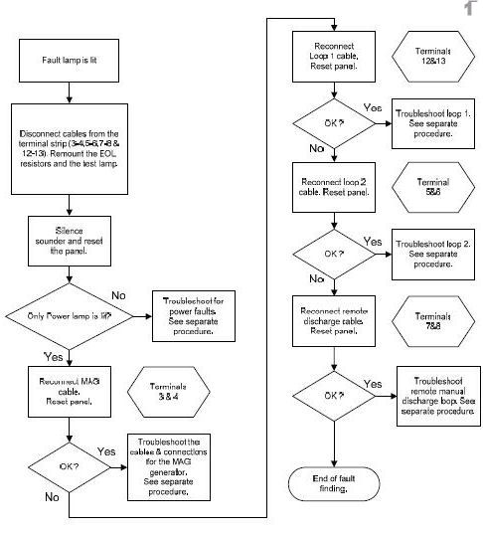

Power lamp out

- Check cables and connections.
- Make sure that the ignition is switched on and that +ve from the ignition switch is connected to the panel.
- Check that + 12/24VDC is connected to the control panel (use a test lamp or multi-meter).

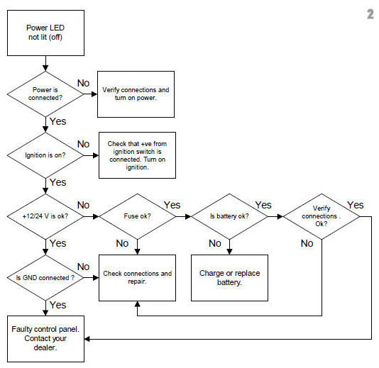

Fault LED lit.

Check PYROGEN Generator

Verify connections and cables for the PYROGEN generator.
Disconnect the wires from terminal 3 & 4 (11&4) and measure the loop resistance (correct value is 2.5 – 4.5 Ω. It is important that if you intend to check the resistance of the Pyrogen generators you should use a digital multi-meter. The maximum test current shall not exceed 50 milliamps for a period of 5 minutes. The monitoring current shall not exceed 5 milliamps.

A check should also be made to the generator cable in the junction box and finally measure directly on the generator connection (pin 1 & 2).
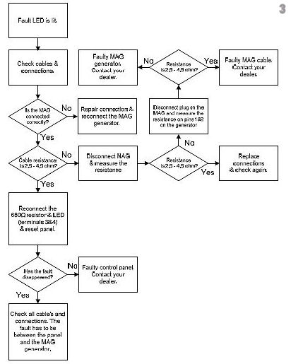

The Fault LED is lit

Check loop 1 – Sensor cable

If a sensor cable is not connected, check that the 47kΩ  resistor is connected at terminal 12 & 13 (yellow).

A digital multi-meter is to be used to measure the loop resistance. Correct value is 47kΩ  
A check should also be made to measure the cables connected in the junction box.

Troubleshooting procedure – sensor cable

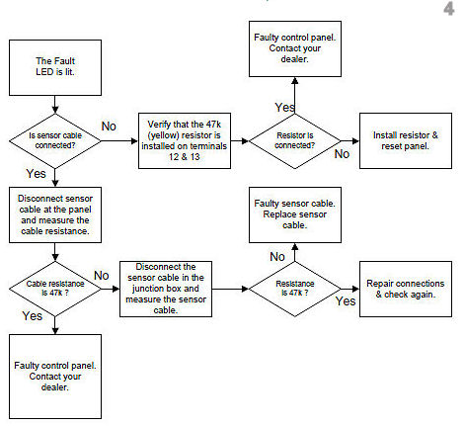

Fault LED is lit

Check loop 2 – Alarm detector(s)

If external detectors are not connected, check that the 23kΩ  resistor is connected at the terminals 5 & 6 (Green).

Check that a detector is connected to loop 2 (terminal 5 & 6), and that the EOL resistors is correct installed in the detector.

A digital multi-meter is used to measure the loop resistance. Correct value is 23kΩ  
A check should also be made to measure the cables connected in the junction box and in the detector.

Troubleshooting procedure – Loop 2

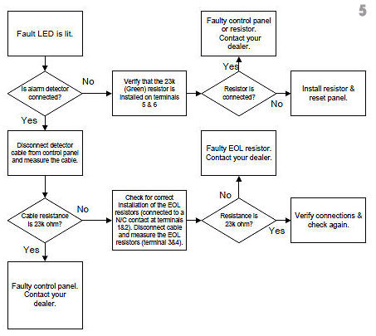

Fault LED is lit
Check external manual discharge loop

If a remote manual discharge button is not connected, check that the 23kΩ resistor is connected at terminals 7 & 8 (Green).

If there is a remote discharge button connected check that it is connected correctly to terminals 7 & 8, and that the EOL resistor is correctly installed in the discharge button.

A digital multi-meter is used to measure the loop resistance. Correct value is 23kΩ  

A check should also be made to measure the cables connected in the junction box.

Troubleshooting procedure – manual discharge

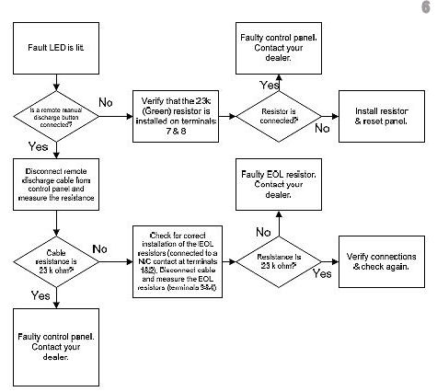

Alarm LED lit

The following situations will cause the “Alarm” Led to lit:

- The Thermal sensing cable connected to loop 1 has a short circuit.
- A short circuit on any cable connected to loop 1.
- A detector connected to loop 2 is in alarm condition.
- An incorrect resistor is fitted at terminals 5 & 6 (Yellow instead of Green).
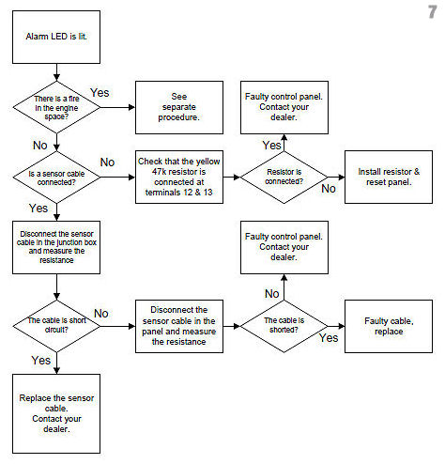

Alarm & Activated LED lit

The following situations causes the Alarm & Activated LED’s to light:

- Alarm detector or sensor cable connected to loop 1 is in an alarm condition and the loop is configured to monitor the Pyrogen generators for pyrotechnical discharge. See the DIP-switch settings on page 27.
- Alarm detector connected to loop 2 is in an alarm condition and the loop is configured to monitor the Pyrogen generators for pyrotechnical discharge. See DIP -switch settings on page 27.
- Terminals 12 & 13 are short circuit and the loop is configured to monitor the Pyrogen generators for pyrotechnical discharge. See DIP-switch settings on page 27.
- The incorrect resistor is installed at terminals 5 & 6 (Yellow instead of Green) and the loop is configured to monitor the Pyrogen generators for pyrotechnical discharge. See DIP switch settings on page 27.

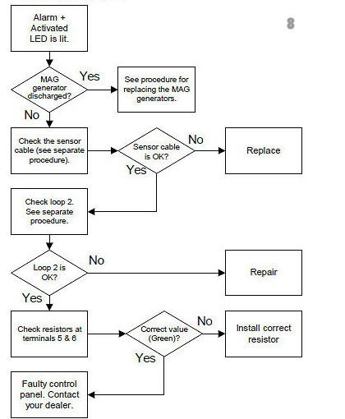

List of delivered items

Included in the PyroSense SP-1e basic kit:

Quantity | Description
1 | Control panel SP-1e
1 | Junction box
1 | Installation & user manual
1 | Area warning sign
1 | Installation & fixing equipment

In addition a Pyrogen generator suitable for the area (V) of the protected space has to be added.

MAG 1 | Dim. Ø75 x 75 mm  Weight 0.65 kg  Discharge type: Mono | Maximum protected volume  0.6 m³ (At 100 g/m³ Design Concentration)  MAG 1 c/w fixing bands & brackets
MAG 2 | Dim. Ø75 x 90 mm  Weight 0.75 kg  Discharge type: Mono | Maximum protected volume  1 m³ (At 100 g/m³ Design Concentration)  MAG 2 c/w fixing bands & brackets
MAG 3 | Dim. Ø75 x 135 mm  Weight 1.0 kg  Discharge type: Mono | Maximum protected volume  2 m³ (At 100 g/m³ Design Concentration)  MAG 3 c/w fixing bands & brackets
MAG 5 | Dim. Ø95 x 135 mm  Weight 2.2 kg  Discharge type: Mono  (MAG 5/2 Bi-directional) | Maximum protected volume  5 m³ (At 100 g/m³ Design Concentration)  MAG 5 c/w fixing bands & brackets
MAG 4 | Dim. Ø95 x 375 mm  Weight 4.0 kg  Discharge type:  Bi-directional | Maximum protected volume  10 m³ (At 100 g/m³ Design Concentration)  MAG 4 c/w fixing bands & brackets

Optional equipment

It is possible to have various types of sensors connected to the control panel. This could be thermal sensing cables, spot detectors (heat & smoke), CO or propane detectors, water leakage detectors etc. The SP-1e can be configured for automatic activation of PYROGEN generators if need be.

In order to avoid disconnecting of PYROGEN connectors prior to doing any work in the engine space an Isolator switch could be fitted. This switch also acts as a test lamp and can be used for testing the system.

PyroSense SP-1e is also configured for use with manual discharge buttons. Break Glass wall pulls and UV/IR optical sensors based on the NO sensor and a 47K ohm E.O.L.

Accessories and spare parts
Description | Specification | Stock number
Pyrogen MAG-generator MAG 1 |  | PYRMAG1
Pyrogen MAG- generator MAG 2 |  | PYRMAG2
Pyrogen MAG- generator MAG 3 |  | PYRMAG3
Pyrogen MAG- generator MAG 4 |  | PYRMAG4
Pyrogen MAG- generator MAG 5 |  | PYRMAG5
Pyrogen MAG- generator MAG 5/2 |  | PYRMAG5/2
SP-1E control panel |  | WEC-SP1-E
Fixing & Installation PyroSense™ Basic Kit |  | TEC-BASIC-01
Bands & bracket for MAG 1,2&3 |  | PYRPY123MSB
Bands & bracket for MAG 4&5 |  | PYRPY45MSB
Sensor cable with EOL resistor 47kΩ (Alarm temp.180°C) | 4 m | TEC-SÆM-H8069-4M
Electrical connector for MAG 1,2 & 3 |  | PYRPYEC123
Electrical connector for MAG 4&5 |  | PYRPYEC45
Electrical Connector FOR MAG123 & 2 Meter Flying Lead | 2 m | TPR-PYRPYEC123
Electrical Connector FOR MAG 45 & 2 Meter Flying Lead | 2 m | TPR-PYRPYEC45
Fire Proof Cable 2x0,75 (Grey) | Per Meter | ABB827500
Thermal Activation Cord (fuse) | 1 m | PYRPYTAF1M
Pyrogen MAG Canister label |  | SPE-PYR-2
Area/Engine Room Warning Sign | Vehicles | SPE-PYR-3
Warning Sounder, Piezo 3-28 V |  | FNO927-089
Warning Sounder, 6-28 V. Continuous or pulsating |  | FNO926-942
Single zone Isolator & Test unit |  | TEC-SZISW
Double zone Isolator & Test unit |  | WEC-ISL-2N
EOL resistors for connecting NC alarm contacts to the SP-1E | Loop 2 & man/d | WEC-EOL-CARD

Installation check list
The control panel is located in an easily accessible location
The power is properly connected to the battery
All sensor & detector cables are properly connected
All discharge cables is properly connected
Area Warning signs are fitted in visible locations

Ensure all cables to the PYROGEN units are not connected! Connect the power to the control panel and switch on the ignition.

The “Power” LED illuminates
“Fault” is indicated at the panel unless the TEST LED is placed in terminals 3 & 4
Short circuit the sensor cable terminals in the junction box
The alarm LED illuminates and the buzzer sounds

Reset the panel

Disconnect the detector cable at loop 2
The Fault LED illuminates and the connected buzzer sounds
Re-connect the detector cable and reset the panel
Activate the alarm detector by disconnecting the NC alarm contact
The alarm LED illuminates and the connected buzzer sounds
Re-connect the alarm contact cable and reset the panel

Connect a test unit, or use the red LED originally placed in terminals 3 & 4, to the PYROGEN generator connector & reset the panel.

Simulate a discharge
(Press, and hold, both discharge buttons, simultaneously, on the front of the control panel for 5 seconds)

The test unit illuminates after a 5 second delay. If test LED, originally supplied is used, it will glow slightly and go brighter after five seconds, dependent on the light in the area at the time tested.
Disconnect the power an re-connect the PYROGEN cables

Connect the power to the control panel and switch on the ignition,

Only the Power LED is lit

Personal statement

The PYROGEN generator has been re-connected after performing the required tests
Distributor: |  | Phone:
Installer: |  | Phone:
Date of installation:

The system functions properly without any faults:
Location. |  | Date. |  | Signature.

Installation log

Please complete, and where required, update the following log.
All future alterations to the system settings, adding of auxiliary equipment or faults etc. are to be recorded in the Service Log.

Date of purchasing:
Casing Serial Number SP-1E:
Casing Serial Number PYROGEN generator(s):
Name & Address of distributor:
Date of installation:

DIP switches settings
In the illustration all the switches are in the OFF position. In order to move switches to the ON position they must be gently pushed up with a pen or pencil, taking care not to damage them.
Please note the final positions of all switches below
In the illustration all the switches are in the OFF position. In order to move switches to the ON position they must be gently pushed up with a pen or pencil, taking care not to damage them.
Please note the final positions of all switches below

NOTE: - (Factory Default)
All panels are delivered with the switches in the OFF position
NOTE: - (Factory Default)
All panels are delivered with the switches in the OFF position

DIP Switch Settings
The position of each switch is marked with a X.
The position of each switch is marked with a X.
ON
OFF |  |  |  |  |  | X
DIP | 1 | 2 | 3 | 4 | 5 | 6 | 7 | 8

Sensor/Detector connected to Loop 1:
Sensor/Detector connected to Loop 2:
Connected Manual Discharge button:
Connected equipment to Out 1:
Connected equipment to Out 2:
Number & type of connected PYROGEN’s:

Service Log

Date | Event | Action | Sign.

Declaration of conformity

Instrument: Fire & Extinguishing control device
Category: Electronic Control Device (ECD)
Type: PyroSense SP-1e
Manufacturer: WestControl AS
Address: Nordmarka
4120 Tau
Norway

WestControl AS conforms to the following Directives and Standards:

EMC: Directive 89/336/EEC

Generic standards: EN50081-1:1992, EN61000-6-3:2001
EN50082-1:1997, EN61000-6-1:2001

Basic standards: EN55022B, EN55025
EN61000-4-2 ESD immunity
EN61000-4-3 Radiated immunity
EN61000-4-4 EFT/B
EN61000-4-5 Surge
EN61000-4-6 Conducted RF
EN61000-4-11 Voltage dips and interruptions
EN61000-3-2 Harmonics
EN50130-4 EMC Alarm

Prepared & developed in harmony with:
EN 54-1 (Fire detection and fire alarm systems - Part 1
EN 54-2 (Fire detection and fire alarm systems - Part 2
CEN/TC 191 (fixed fire fighting systems) prEN 12094-1

Furthermore WestControl AS declares that the SP-1E, based on internal tests conducted at WestControl EMC laboratory, is fully compliant with the Automotive Directive 95/54/EC. A formal type approval testing, as required by 95/54/EC, is currently being conducted at a certified approval body in order to obtain type approval certificates required for both the ‘e’ and ‘E’ marking.

Tau 07.12. 2004

WestControl as
Quality Assurance

M Dreggevik

The product meets the requirement of 89/336/EEC (EMC Directive)
and the Automotive Directive 95/54/EC.


Installation diagram Basic Kit

Function:

This is the basic configuration of the PyroSense extinguishing system. The SP-1e control panel (EQ-01) is installed nearby the driver position and has attached a heat sensing detector cable (EQ-06), external buzzer (EQ-08) and a number of PYROGEN canisters (EQ-03 to EQ-05).
Power is connected to the panel from the bus fuse box (24 V DC/3Amps). In order to save power when unattended the panel has a control input supplied from the ignition switch or main switch.
The SP-1e is configured for automatic discharge if the Heat sensing cable has detected a fire.
At temperatures >180ºC the heat sensing cable will short circuit and the panel will activate the alarm.
The alarm will sound for 15 seconds prior to discharge of the Pyrogen generator/s.

Discharge of PYROGEN generators also can be activated by simultaneously pressing, and holding, the two pushbuttons, on the front of the control panel, marked "Press" for minimum 5 seconds.
A pulsating sound will confirm that manual discharge signal is activated. After 5 seconds the sound will stop pulsating and a constant sound will be heard. At this moment the PYROGEN generator will be discharged into the protected engine space and extinguish the Fire within seconds.

Installation diagram optional Webasto cabin heater protection

Function: Bow thruster GenSets
In addition to the basic setup, protection of a separate cabin heater space or bow thruster can be added. A PYROGEN generator fitted with a linear thermal activation device can be installed in the space.

Thermal activation of the Pyrogen generator is provided by action of an inbuilt thermal ignition device & the linear thermal activation cord, which automatically ignites at ≤175° C or when exposed to a naked flame and propagates ignition to the solid aerosol-forming composition. When the PYROGEN activates it will allow a NO thermal switch to change state and will trigger an Alarm on the SP-1e control panel.
Thermal Electrical Activation
Pyrogen also provides electrical thermal activation via our T-Start thermal activation device. This device operates like a sprinkler head, and activated at a pre determined temperature. As the spring drives the magnet down through the coil it makes a current that provides electrical activation to the PYROGEN generator. It is available in several activation temperatures. (45^{C}, 72^{C}, 110^{C}) They can also be fitted with a pull cable for manual activation and a Junction Box with magnetic switched to provide EOL logic to the SP-1e or relay logic to other ships systems.

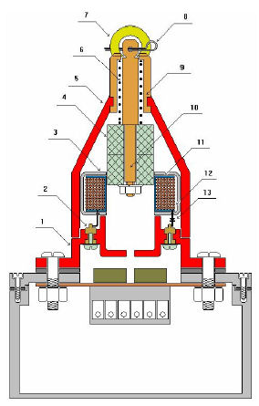 | 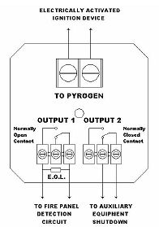 | 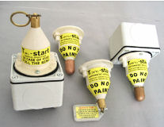

Installation diagram optional delayed discharge

Function:

For some systems it may be necessary to have a secondary discharge shortly after the first to aid concentration hold times due to unavoidable losses. The SP-1e control panel can be configured to discharge a second loop after a 5 or 10 seconds delay. The number of PYROGEN generators connected in series to this second loop must not exceed a total resistance of 12Ω.
The configuration above is for a 10 seconds delay.

Installation diagram optional Isolator switch

Function:
Prior to any work in the protected area it is absolutely necessary the Pyrogen generators are disconnected in order to prevent an unintentional discharge. This can be done manually by disconnecting each PYROGEN connector, or by use of Isolator switch. This switch can also be used for testing the system as it, when set in isolated mode, acts as PYROGEN generators to the SP-1e control panel. A LED at the front of the Isolator switch indicates both monitoring current (slight glow) & activation current (bright glow).
The switch can be fitted nearby the driver and the SP-1e control panel.

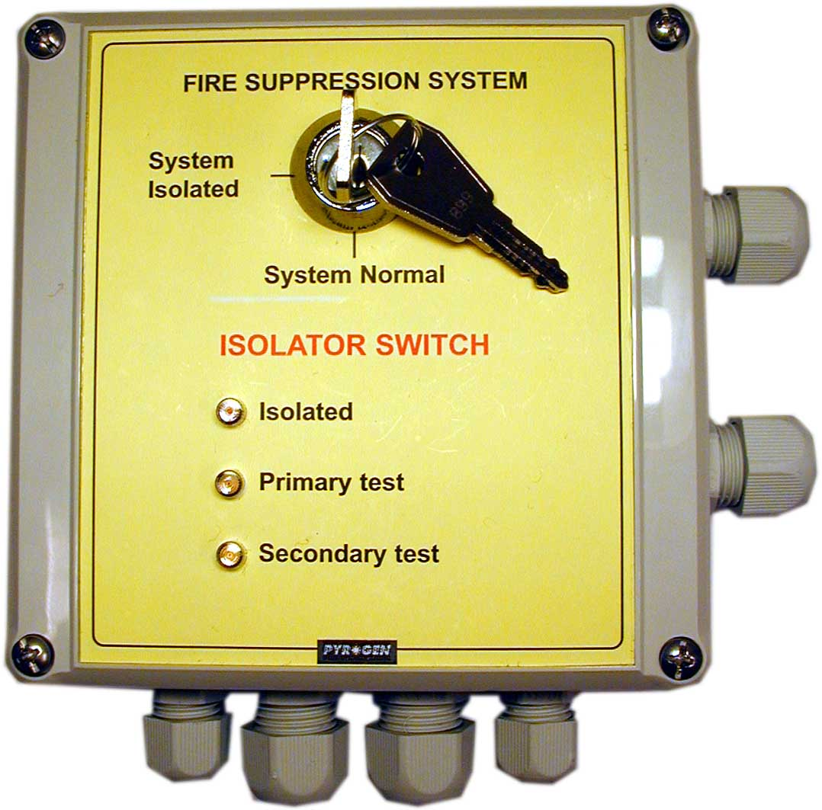 | 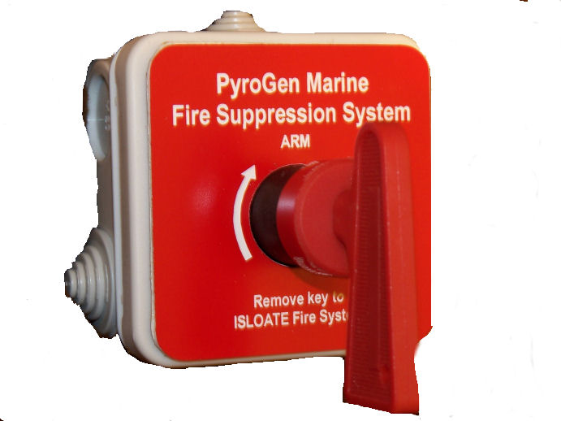
Installation diagram optional Manual discharge button

Function:
Discharge of Pyrogen generators can be activated by simultaneously pressing, and holding, the two red pushbuttons, on the front of the control panel, marked "Press" for minimum 5 seconds.
In addition to the pushbuttons on the front of the control panel an optional external Manual discharge button can be fitted to the system. This input is monitored for short circuit or broken loop by the SP-1E control panel.

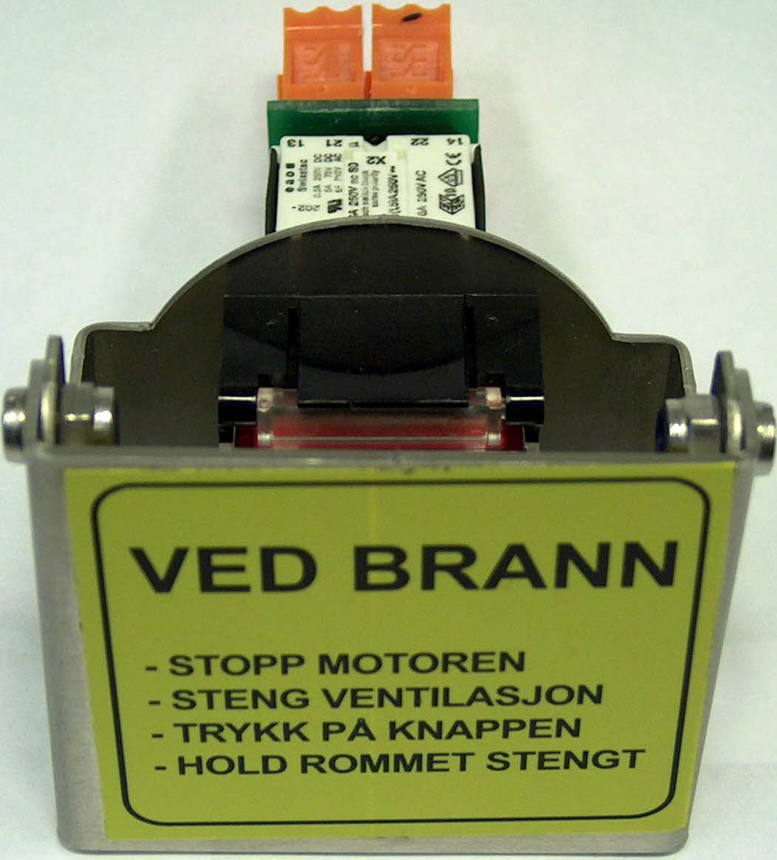

External Manual discharge button

Installation diagram optional automatic Fan stop

Function:

The SP-1E control panel has an output, which can be used for automatic fan stop (electrical controlled fans only). The output (10 & 11) is open collector controls signal with voltage the same as connected power supply. If automatic Fan stop is configured for digital input control signals, a relay must be connected in between as shown below.

Installation diagrams for the connection of Alarms

Sensors using normally open “NC” alarm contacts

2
3
1
Connect to 5 & 6 on the SP-1e
EOL Resistors
The alarm contact must be of Normally Closed type and is connected to the Loop 2 of the SP-1e through a resistor network as shown. Both resistors are 47kΩ

47kΩ

47kΩ

47kΩ

47kΩ

When there is more than one Alarm connection required to Loop 2 on the SP-1e

Alarm Contact 1
Alarm Contact 2
Alarm Contact 3
2
3
1
EOL resistor is installed in the last Alarm unit

47kΩ

47kΩ

Instead of wiring the resistors yourself an EOL card with resistors fitted could be used.
4
3
2
1
Normally closed contact
(
NC
)
Input loop
2
or manual
discharge on SP
-
1
(
5
-
6
&
7
-
8
)
EOL
-
Card

Instead of wiring the resistors yourself an EOL card with resistors fitted could be used.

Sensors using normally open “NO” alarm contacts
General connection of Normally Open Alarm (NO) Contacts to loop 1 of the SP-1e

Connect to terminal 12 & 13 on the SP-1e
47kΩ

Connection of more than one Alarm Contact to loop 1 of the SP-1e

Optional Isolator switch
Resistor 47kΩ
Alarm Contact 3
Alarm Contact 2
Alarm Contact 1
47kΩ

Resistor 47kΩ
Alarm Contact 3
Alarm Contact 2
Alarm Contact 1
47kΩ

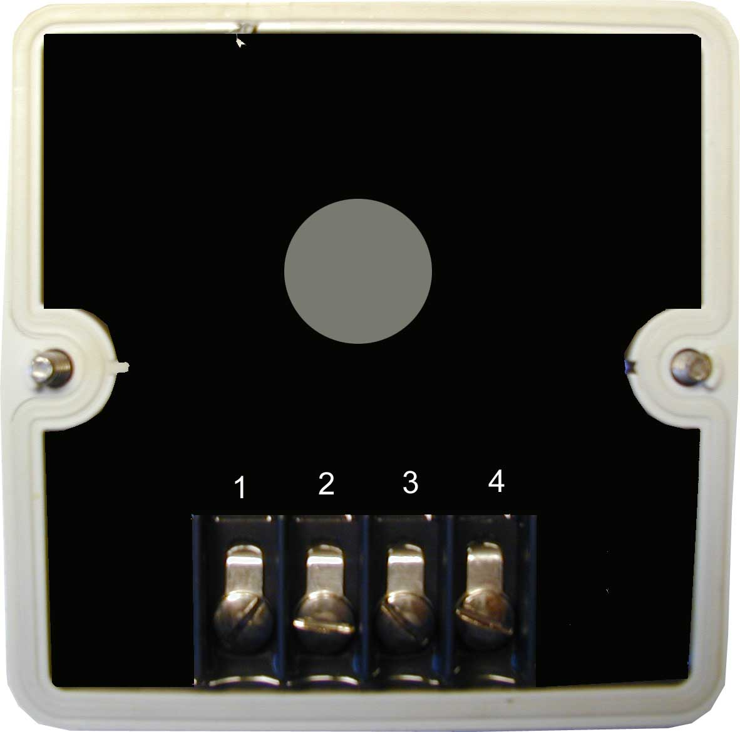
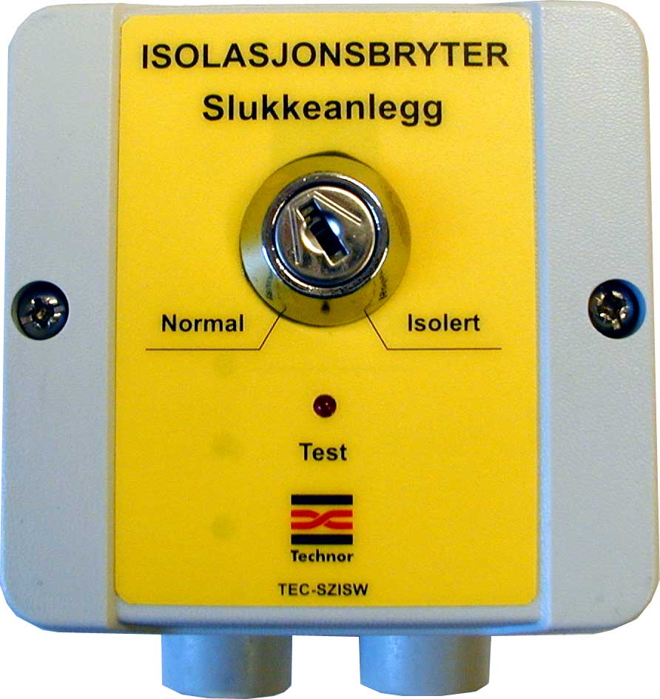

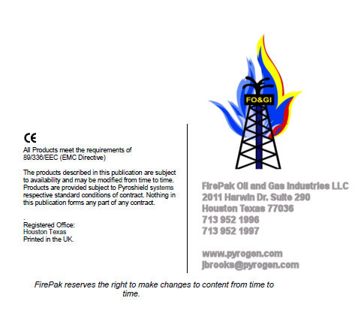

Input loop 1 is monitored for break and input loop 2 & external manual discharge input are monitored for both short circuit and break. The MAG loop is monitored for break.
If this function is used
A blocking diode must be used if output 1 is connected to an existing sounder.
If this function is used.
On each loop if the panel is configured for extended discharge by use of 2 MAG loops.
? R1=47kΩ in serial with NC alarm contact, and R2=47k in parallel with the NC alarm contact and R1.
R1=47kΩ in serial with NC alarm contact, and R2=47k in parallel with the NC alarm contact and R1.
Depending upon specific resistance of connected MAG generators. Max. allowed resistance 12 VDC: 10Ω 24 VDC: 20Ω
Max same time load for the out 1 & out 2 are 2 Amp.
Max same time load for the out 1 & out 2 are 2 Amp.
Depending upon specific resistance of connected MAG generators. Max. allowed resistance 12 VDC: 10Ω 24 VDC: 20Ω
If fitted in separate box
Depending upon environmental exposure, the MAG canister lifetime is guaranteed from 1 to 10 years.
Use the same procedure for the second MAG if connected/configured.
See “Determining the quantities of MAG canisters” on page 19

